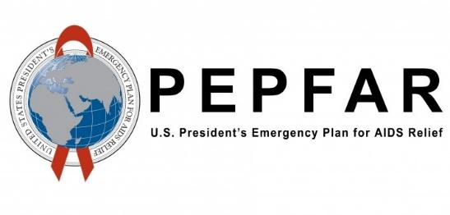
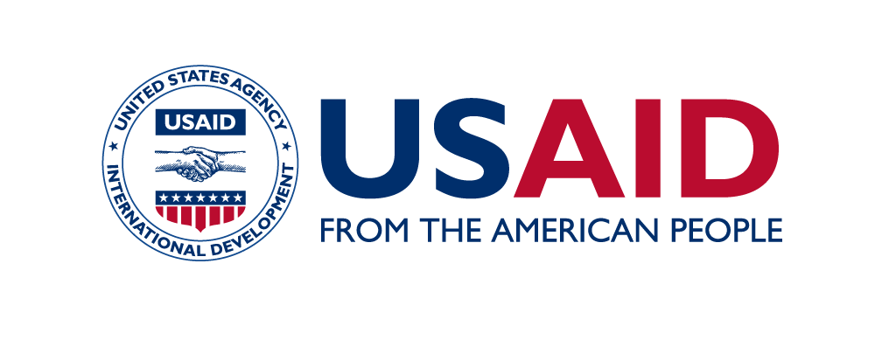
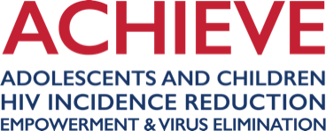
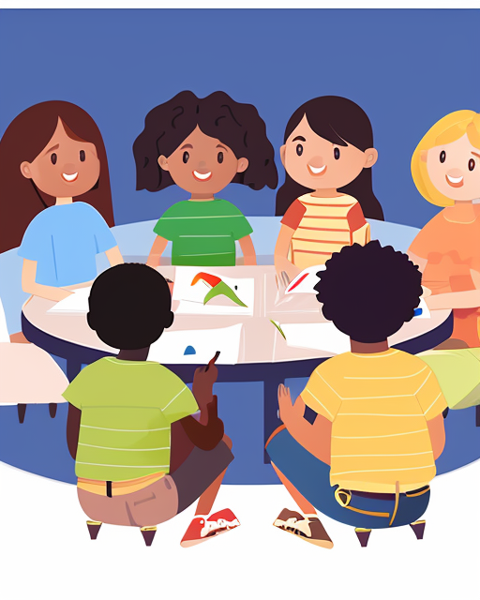
Photo Credit:

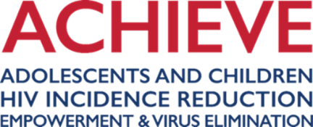
a toolkit on developing child-friendly child safeguarding communications and materials

September 8, 2023

This Toolkit is made possible by the generous support of the American people through the United States Agency for International Development (USAID) and the U.S. President’s Emergency Plan for AIDS Relief under the terms of Award No. 7200AA19CA00006. The contents are the responsibility of Pact and do not necessarily reflect the views of USAID, PEPFAR, or the United States Government.

ABOUT ACHIEVE
Adolescents and Children, HIV Incidence-reduction, Empowerment, and Virus Elimination—ACHIEVE— is USAID’s flagship initiative to address the needs of children, young people, and breast-feeding women affected by HIV. This includes supporting local organizations in serving these populations and ultimately building their capability to receive direct U.S. government funding for programs at scale. The project leverages the full strength of its consortia and related private and public sector stakeholders to support countries attain and sustain HIV epidemic control. Led by Pact, core consortia partners include Jhpiego, Palladium, No Means No Worldwide, and WI-HER.
ABOUT KEEPING CHILDREN SAFE

Keeping Children Safe (KCS) sets International Child Safeguarding Standards to help organizations protect children from abuse. KCS is completely independent and guided by the best interests of the child principle in all that it does. KCS works with people who have been subjected to child abuse, researchers, practitioners, policymakers, and leaders to defend children’s’ right to be safe in all organisations, no matter how big or powerful.

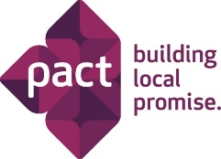

Pact. Keeping Children Safe
1140 3rd St. NE, Suite 400 49 High Street, Skipton, North Yorkshire
Washington, DC 20002 BD23 1DT, United Kingdom

Tel: 202.466.5666
www.pactworld.org/achieve www.keepingchildrensafe.global

Acknowledgements

Stefan Yordanov, Senior Child Safeguarding Programme Manager, Keeping Children Safe.
Maury Mendenhall, Senior Technical Advisor, Orphans and Vulnerable Children
USAID, Office of HIV/AIDS
Colette Bottini Peck, MSc Senior Orphans and Vulnerable Children (OVC) Advisor
USAID, Office of HIV/AIDS
Wezet Botes, Social Protection Specialist USAID
Jennifer Mulik, MA, MPH Project Director, ACHIEVE
Tom Ventimiglia, Deputy Director, ACHIEVE
Amelia Peltz, Senior Gender Advisor and Team Lead, Office of HIV/AIDS, USAID
Okello Opok Fred Peter, Program Management Specialist – OVC USAID Uganda
Brenda Yamba, PhD Senior OVC Advisor USAID Contractor Office of Education, Youth, and Child Development (EYCD) USAID/Uganda
Ann K Bloome, Technical Writer, Pact
Luisa Fontanazza, Design and Impact Specialist, Keeping Children Safe

Contents

Acknowledgements 3
Acronyms 5
Introduction 6
Purpose 6
Who is this toolkit for? 6
How to use this toolkit? 6
Definitions of harm 7
Child Protection and Child Safeguarding 8
The International Child Safeguarding Standards (ICS) 9
Standard 1: Policy 10
Standard 2: People 12
Standard 3: Procedures 15
Standard 4: Accountability 18
Why should USAID implementing partners (and USAID) care about child safeguarding? 19
What minimum safeguarding measures must be in place before using this toolkit? 21
Section 1: Communication with Children 29
Section 1.1: Child Participation 29
Section 1.2: Core principles of communication with children 30
Section 1.3: How to speak with children about abuse and safeguarding 36
Section 1.4: First-Line support for children and adolescents at risk of or experiencing violence 44
Section 2: Designing Child-friendly documents 50
Section 2.1: Developing a child-friendly version of your child safeguarding policy 56
Section 2.2: Guide to developing your child-friendly reporting and responding mechanism 57
Section 3: Resources 63
Section 3.1: Templates 65
Section 3.2: More links to additional useful resources 80

Acronyms

ACHIEVE Adolescents and Children, HIV Incidence Reduction, Empowerment, and Virus Elimination
AIDS Acquired Immunodeficiency Syndrome
AO Agreement Officer
AOR Agreement Officer’s Representative
CO Contracting Officer
COR Contracting Officer’s Representative
C-TIP Counter-Trafficking in Persons
DREAMS Determined, Resilient, Empowered, AIDS-free, Mentored, and Safe
HIV human immunodeficiency virus
ICS International Child Safeguarding
IP implementing partner
LIVES Listen, Inquire, Validate, Enhance safety and Support
LIVES CC LIVES Child and Adolescent Friendly Environment / Caregiver Support
NGO non-governmental organization
OIG Office of Inspector General
OVC orphans and vulnerable children
PEPFAR President’s Emergency Plan for AIDS Relief
PSEA Protection from Sexual Exploitation and Abuse
UN United Nations
UNCRC United Nations Convention on the Rights of the Child
US United States
USAID United States Agency for International Development
VAC violence against children
WHO World Health Organization

Introduction

Purpose
There has been a growing recognition that, as well as risks to children from staﬀ and associates, inappropriately designed programs and poor operational management can also create the possibility of risks to children. All projects and programs must be designed to minimize the risk of harm to the children they come into contact with or impact upon directly or indirectly by taking suﬃcient account of child safety, whatever the focus of the work.
A child safe program must ensure that it takes account of the environment, local context, and impact (intended or unintended) on the children and communities with which it engages. All organizations must therefore determine the context in which they are working and adopt child-friendly approaches that include adapting policies and procedures for children, so they become aware of the organization’s safety strategies.
The purpose of this toolkit is to provide knowledge and information to encourage and facilitate reporting of child safeguarding concerns by children and adolescents, and to raise awareness among children and adolescents who participate in PEPFAR-funded programs of their rights with regards to safeguarding.
All tools and resources in this toolkit can be adapted to fit the specific country or local context.

Who is this toolkit for?
This guide is designed to guide orphans and vulnerable children (OVC) programming and other (clinical, community-based, volunteer and DREAMS) staff of the implementing partners (IPs) in different countries on how to adapt, develop and set up child-friendly reporting and responding mechanisms, including how to communicate children’s rights to children and adolescents. It can be used by staff members who will be communicating and sharing information with children.

How to use this toolkit?
This toolkit provides an overview of what you need to do to develop or strengthen child-friendly reporting and responding mechanisms. The steps described in Sections 1 and 2 will help you indicate key actions that should be taken to establish child-friendly reporting as a core component of your programming. Section 3 provides a range of tools, examples and templates that accompany this guide, which cover in more depth how to adapt, develop, and set up child-friendly reporting and responding mechanisms.

Definitions of harm

Child abuse and maltreatment can take different forms: in a family, an institution, community, faith setting, or via social media or the internet. Children may be harmed by an adult or adults or another child or children. These terms are defined in many different national and international contexts. For the purposes of USAID, these terms are already specifically defined.
Child abuse, exploitation, or neglect constitutes any form of physical abuse; emotional abuse, or ill-treatment; sexual abuse; neglect or insufficient supervision; trafficking; or commercial, transactional, labor, or other exploitation resulting in actual or potential harm to the child’s health, well-being, survival, development, or dignity. It includes but is not limited to any act or failure to act which results in death, serious physical or emotional harm to a child, or an act or failure to act which presents an imminent risk of serious harm to a child.
Physical abuse: Constitutes acts or failures to act resulting in injury (not necessarily visible), unnecessary or unjustified pain or suffering without causing injury, harm, or risk of harm to a child’s health or welfare, or death. Such acts may include but are not limited to punching, beating, kicking, biting, shaking, throwing, stabbing, choking, burning, or hitting (regardless of object used). These acts are considered abuse regardless of whether they were intended to hurt the child.
Sexual abuse: Constitutes fondling a child's genitals, penetration, incest, rape, sodomy, indecent exposure, and exploitation through prostitution or the production of pornographic materials.
Neglect: Constitutes failure to provide for a child's basic needs within USAID-funded activities that are responsible for the care of a child in the absence of the child's parent or guardian.
Emotional abuse: Constitutes injury to the psychological capacity or emotional stability of the child caused by acts, threats of acts, or coercive tactics. Emotional abuse may include but is not limited to humiliation, control, isolation, withholding of information, or any other deliberate activity that makes the child feel diminished or embarrassed.
Exploitation: Constitutes the abuse of a child where some form of remuneration is involved or whereby the perpetrators benefit. Exploitation represents a form of coercion and violence that is detrimental to the child’s physical or mental health, development, education, or well-being.
Learn more about the indicators of harm and signs of abuse.

Child Protection and Child Safeguarding

Child Protection refers to the protection of all children from violence, exploitation, and abuse, per Article 19 of the United Nations Convention of the Rights of the Child (UNCRC). In the international context it describes the work being undertaken to strengthen laws, policies, and systems designed to protect children in each country, in his or her own family and community.
According to UNCRC Article 19, child protection requires action.
- Parties shall take all appropriate legislative, administrative, social, and educational measures to protect the child from all forms of physical or mental violence, injury or abuse, neglect or negligent treatment, maltreatment, or exploitation, including sexual abuse, while in the care of parent(s), legal guardian(s) or any other person who has the care of the child.
- Such protective measures should, as appropriate, include effective procedures for the establishment of social programs to provide necessary support for the child and for those who have the care of the child, as well as for other forms of prevention and for identification, reporting, referral, investigation, treatment, and follow-up of instances of child maltreatment described heretofore, and, as appropriate, for judicial involvement.

‘Do no harm’ is a principle that has been used in the humanitarian sector but can equally be applied to the development ﬁeld; it refers to organizations’ responsibility to minimize the harm they may do inadvertently during organizational activities.

Child Safeguarding is a set of policies, procedures, and practices that an organization employs to ensure that it itself is a child safe organization. It is the responsibility that organizations must ensure their staff, operations, and programs ‘do no harm’ to children and that any concerns the organization has about children’s safety within the communities in which they work are reported to the appropriate authorities.

The International Child Safeguarding Standards (ICS)
Everyone involved in working with children has a fundamental duty of care towards them. We must all recognize the risks to children of abuse and exploitation and our responsibilities to keep them safe, during humanitarian emergencies and as part of longer-term development efforts. In building safe environments for children where their rights are respected, and they are protected from harm, staff and other representatives of aid and development agencies have an important part to play. This means making sure that development professionals understand their safeguarding roles and responsibilities, and that they always behave with the utmost professionalism and integrity. For this to happen consistently, we need to have a systematic approach to child safeguarding. Standards are used widely in all sectors to ensure quality in the delivery of a product or service, and accountability to those who are using or benefiting from them.
The first International Child Safeguarding Standards were launched in 2002 by a coalition of relief and development charities that later became known as Keeping Children Safe. The Standards describe good practice for organizations to ensure their programs, operations, staff, and partners do not put children at risk of harm and to enable them to respond appropriately when concerns and incidents arise.
As such, these Standards provide a comprehensive benchmark for preventing harm to children and are complementary to other standards and principles. Organizations which are already working to a set of standards such as those highlighted above, should use Keeping Children Safe standards to ensure their quality and accountability initiatives do include children and safeguards for children.
The Standards are written in a way that makes them relevant and achievable in all contexts. However, they may be more difficult or challenging to implement in some countries and local contexts than in others. Examples of some of the difficulties that have arisen in applying the Standards locally are:
- Reporting abuse to local or national authorities may not be straightforward if the reports are not handled properly. There are, however, always organizations working nationally and locally that can provide advice on reporting cases, and local mapping will identify these.
- Applying standards of practice that are not supported by national law; for instance, where the age of consent is less than 18 years and where young people under age 18 are legally able to work can be problematic. However, organizations must remember that Keeping Children Safe Standards are designed to prevent harm to all children under 18.
There are enormous variations in local practice and circumstances but experience in applying the standards in different contexts demonstrates that they do not need changing or diluting because of cultural or contextual differences. Nor do harmful practices have to be tolerated or condoned. Organizations should discuss how best to apply the standards in the local context, what behavior they should demand of their own staff and partners and how they want to be credible as child-safe organizations.

The advantages of implementing ICS are:
- Children are protected: No standards can offer complete protection for children, but following these Standards minimizes the risk to children of harm.
- Organization staff and associates are protected: By implementing these Standards, all staff and associates will be clear about how they are expected to behave with children and what to do if there are concerns about the safety of a child.
- The organization and its reputation are protected: Implementing these Standards makes clear the commitment of an organization to keeping children safe, and to move toward best practice in this area.

Standard 1: Policy

  - Your organization develops a policy that describes how it is committed to preventing and responding appropriately to, harm to children.

What is the Standard?

All organizations whose work affects children need to develop a clear child safeguarding policy that prevents harm to children and outlines what measures are in place to respond when safeguarding concerns arise.

Why should organizations meet this Standard?

Developing a child safeguarding policy makes it clear to everyone that children must be safeguarded and not put at risk of harm because of the organization’s contact with, or impact on, children.

How to meet the Standard?

- Designing the policy

A good child safeguarding policy is developed through consultation with staff and associates and, where appropriate, children, local leadership, and communities. If you want your safeguarding policy to be effective, you need to make sure it is central to the organization, and that different parts of the organization have been consulted on its development and implementation.
Use a working group or task team to lead on the development of the policy. To design your policy, you will need to:
- Understand the level of contact, or impact upon children that your organization has as part of its activities and the associated risks.
- Identify what policies and procedures already in place which support child safeguarding, such as good recruitment practices, and define any gaps.
- Determine what your policy must include so that risks to children are reduced and strengthen your organizational policies and procedures.
- Identify the key stakeholders who need to be involved in the development, implementation, and ownership of your policy.
Child safeguarding policies should:
- Express the philosophy of your organization: set out what the organization wants to say about how it keeps children safe.
- Recognize the needs of all children to be safeguarded: state explicitly that the organization is committed to safeguarding all children, irrespective of ability, ethnicity, faith, gender, sexuality, and culture. The policy should also recognize that types of risk may vary according to the child and that the means of addressing risks may also vary.
- Always apply to all staff and associates: make explicit that preventing harm to children should be a commitment staff and associates make whilst at work and outside of work. Staff and associates need to understand that they represent, or are identified with, the organization.
- Identify and manage risk: describe how an organization will identify and manage risk. Having a child safeguarding policy does not mean that all harm to children is eliminated. It means that the organization does everything possible to minimize risk and address concerns and incidents appropriately when they arise.
- Integrate safeguarding measures into all areas of the organization: provide an overarching commitment to preventing harm to children. The policy should refer to organizational policies and procedures in all areas of the organization which support child safeguarding and include confidential reporting mechanisms for child safeguarding concerns.

- Writing the policy

The policy should be written in a manner that is globally and locally appropriate. Where necessary, it needs to refer to other organizational policies which support child safeguarding. The policy should contain, or refer specifically to, a code of conduct for staff and associates. It needs to be translated to ensure all staff and associates understand it and presented in a manner that is readily understood by all relevant communities, including children.

- Signing off on the policy

The senior management team and the organization’s board need to sign off on the policy. This means they have committed to providing leadership on child safeguarding - ensuring that it is implemented fully, that all concerns or incidents are addressed appropriately, and that children, staff and associates receive the support required to meet commitments and obligations. A date should be set to review the policy and a process put in place to evaluate its impact.

- Publicizing the policy

The policy should be made available to all staff and associates, partners, children, and communities.
This could include:
- Presenting a poster of the organization’s commitments in public places such as meeting spaces and office reception areas
- Ensure a copy is available on the organization’s intranet and internet sites
- Enclosing a copy of all contracts and service level agreements
- Presenting the key requirements as part of the introduction to the organization for sponsors and donors.

Ways of providing evidence:

The following documents can be used to provide evidence that the Standard has been met:
• A copy of the policy signed by the management board.
• Policy translated into local languages.
• Examples of ways the policy has been promoted to partners, children, and communities.

Standard 2: People

Your organization places clear responsibilities and expectations on its staff and associates and supports them to understand and act in line with these.
What is the Standard?
Everyone connected to the organization should know how to keep children safe and have appropriate learning opportunities to develop and maintain the necessary attitudes, skills, and knowledge to keep children safe.
Partners, including IPs funding partners, and those organizations that contribute to business operations, should have child safeguarding measures consistent with these Standards.
Children and families should understand your commitment to child safeguarding and what to do if concerns arise.
Why should organizations meet this Standard?
Everyone in contact with children has a role to play in their safeguarding. They can only do this confidently and effectively if they are aware of the issues and have the necessary understanding and skills to keep children safe.
Organizations need to ensure that all those associated with the organization understand what is meant by harm to children, what their obligations are to prevent harm, and what to do if harm arises.
How to meet the Standard?
- Designating roles and responsibilities for child safeguarding

All organizations should have a named, designated person who is responsible for making sure that the child safeguarding measures are integrated throughout the organization and acts as a focal point.
This role should reflect the nature and structure of the organization and the person should be senior enough, and have enough support and resources, to carry out the role. At each appropriate level or setting there should be a named person or persons who people can talk to about child safeguarding matters. It is good practice to identify within your organization the designated person and everyone should know how to contact him or her.
In larger organizations there should be a structure identifying several designated people across the different regions and activities.
You may wish to add to this or develop the role according to your organizational needs. However, the designated person should not normally be a head of service or have sole responsibility for the management of child safeguarding for an organization. It is always better to ensure there are other lines of accountability and responsible people so there is not one reporting route only.
- Recruitment and engagement of staff and associates

The organization should outline its commitment to child safeguarding at the earliest opportunity in recruitment adverts, interviews and as part of contracts of employment. Staff, consultants, and volunteers should be recruited to clear job or role descriptions that include a statement on the position or the role’s responsibilities to meet the requirements of the organization’s child safeguarding policy.
All interviews should include a discussion on child safeguarding, the candidate’s understanding of this and the organization’s commitment. Contract offers for those whose work will bring them directly into contact with children, or gain them access to children’s information, should be dependent on suitable references and criminal record checks.
- Guidelines for staff conduct.

A code of conduct is a clear and concise guide of what is and is not acceptable behavior or practice when employed or engaged by the organization. It should include acceptable and unacceptable behavior with regards to children. All staff and associates, including volunteers, should agree to the code of conduct when they are employed and/or start their job. It is an essential element of an organization’s child safeguarding policy and, when implemented properly, should reduce, or limit the risk of child abuse occurring. It should also be made clear what action the organization will take if the code is broken or not followed correctly.
Staff who work for organizations with a child safeguarding policy and code of conduct need to follow that code within and outside the workplace. This means adopting appropriate behavior themselves and reporting on concerns they have about a child whether in work or outside. This can often present a challenge for staff, but it is important to understand that the organization is creating an environment that contributes to keeping all children safe.

- Training and education

Education and training are very powerful ways to improve practice. It is essential that all those employed or engaged by the organization have access to regular training on child safeguarding that is appropriate for their role and responsibilities, beginning at the induction/orientation stage.
Staff with designated responsibilities for child safeguarding need to have access to advice and support where concerns or incidents arise. These staff will also need to be able to identify sources of support for children and their families.
- Agreements with partners

An organization will have a range of partners, including donors, local NGOs, government, contractors, and suppliers. All need to agree to a commitment to keep children safe that is appropriate to that partnership and has clear language about the following.
- Partners are clear about the nature of the partnership relationships that they enter.
- There is a sound assessment of the partner’s contact with, and impact on children during the partnership and what this means for child safeguarding agreements.
- Agreement is reached on how your organization and the partner will support one another to achieve compliance and competence around child safeguarding, including the provision or exchange of resources.
- Partnership agreements delineate reporting and responding to child safeguarding concerns.
For instance: what is the line of responsibility for reporting between partners? What are the implications for the partnership agreement of concerns being reported and confirmed?
- Termination should be dependent on the partner’s mishandling of the concern; terminating agreements based solely on concerns being raised should be avoided.

- Partnerships with children and families

Your organization can develop partnerships with families and communities that are appropriate to support your work on safeguarding. To ensure effective safeguarding policies, you or your partner organizations will need to ensure implementation of the following procedures.
- All partners must ensure that parents, children, and relevant others know about your child safeguarding commitments and measures. Communications between the organization and parents/carers/community leaders should take account of language or communication differences.
- Your organization and its partners should develop a complaints procedure with children, families, and communities, and publicize it to make sure that everyone knows about it.
If your organization works with children, then you have scope to do the following:
- Encourage the involvement of parents, caregivers, and communities as much as possible through, for example, membership on committees or steering and planning groups as well as involvement in day-to-day activities.
- Ensure you know who has responsibility for the care of a child in any program or project and have a record of their contact details.
- Make sure that staff are easily identifiable when at work, for example by wearing a T-shirt or badge.
- Obtain parental or primary caregiver consent for children’s participation in activities whenever possible.
- Involve parents and children in developing codes of good behavior for staff and for children, for instance in designing anti-bullying guidelines.
- Devise ways of obtaining feedback from parents, caregivers, and communities to find out what you are doing well, what is not working and to check what people know about the organization and how it operates.
- Discuss with children what makes them feel safe and unsafe and agree on ways for children to complain if they have a concern about themselves or their friends.
- Devise a process for ensuring children are consulted and their voices are heard, and that their views inform and influence the development of organizational safeguarding measures.

Ways of providing evidence:

- A copy of training plans, course attendance records and course evaluations
- Copies of information for children about sources of support
- Lists of contacts for specialist advice and information
- Partnership agreements, funding application and reporting forms
- Codes of conduct.

Standard 3: Procedures

Your organization creates a child-safe environment through implementing child safeguarding procedures that are applied across the organization.

What is the Standard?
Safeguarding policy commitments are integrated into existing organizational processes and systems and, where necessary, new procedures introduced. The procedure details the steps that need to be carried out to fulfil the policy.
Why should organizations meet this Standard?
Child safeguarding measures need to be integrated throughout an organization’s systems, processes, and operations to ensure the organization is child safe because simply publishing a commitment to keep all children safe is unlikely to inspire the necessary changes within an organization.
This Standard helps organizations take the necessary steps to integrate safeguarding requirements and ensure the actions are globally relevant and locally appropriate.

How to meet the Standard
Child safeguarding measures must be integrated in an organization’s systems and processes for both different countries and local contexts. The measures must work for the local context but also adhere to global and regional standards.
There need to be consultations with staff across the organization in order to give clear guidance on these issues and how to respond when concerns arise. Child safeguarding measures must be sensitive to the local culture but the issue of who is a child and what constitutes abuse is clearly set out in global and regional standards and frameworks and must be applied across the board.
Definitions of ‘child’ and ‘child abuse’ may differ according to national and cultural understandings. However, organizations need to be clear that ‘children’ are defined as anyone less than 18 years of age and that “abuse” is the range of acts, intentional or otherwise, which harm children.
Organizations also need to be prepared to act locally when concerns arise. They will therefore need to have information on local services, authorities to whom reports should be made, and organizations working locally, which can provide support where needed.
Organizational systems and processes for running organizational business may differ across offices, regions, and countries. They must be risk assessed in each locality and strategies developed for integrating child safeguarding where relevant.
Risk and how to avoid risk are now a major part of many organizations’ working strategy. The more we talk about and recognize risk, the more we can think about preventing it.
Risk assessment involves seven stages:
- Establishing the context, scope and setting of your organization.
- Identifying your organization’s potential impact on or contact with children.
- Identifying and analyzing the potential risks of that impact or contact.
- Evaluating the risks in terms of likelihood they could occur and the seriousness of the impact on children.
- Implementing strategies to minimize and prevent risk.
- Reviewing and revising risks and preventative measures.
- Communicating and consulting.
The below list can help organizations assess their risk in terms of context, scope and impact on or contact with children:
- Is your organization located in places where child abuse is prevalent?
- Is your organization located in places where laws and authorities are weak in responding to child abuse?
- Does your organization involve working with children?
- Does your organization impact upon communities and children?
- Does your organization bring staff and associates in contact with children?

- Implementing strategies to prevent/minimize risk.

There are various steps an organization can take to encourage a culture of safety in their work and workplaces and prevent or reduce the risk of harm to children. These Standards recommend the following actions when integrating child safeguarding measures throughout the organization to address and mitigate risks.
- Organizational culture: changes may need to be made to the culture of the organization so that child safeguarding is considered relevant and important, and so it is transparent about how it addresses concerns and incidents. Organizational culture is determined by a range of factors including management and leadership style, focus of business and, in some cases, where it is located.
- Roles and responsibilities: changes will need to be made to existing roles and responsibilities to ensure that responsibilities are clearly articulated for staff with specific safeguarding roles, and new roles may need to be introduced (see Standard 2 which covers this).
- Policies and procedures: existing policies and procedures will need to be adapted to integrate child safeguarding, including recruitment and selection policy and procedures and the staff code of conduct. New policies and procedures may need to be introduced such as a whistle-blowing policy to support staff who raise concerns.
- Systems and processes: existing systems and processes will need to be adapted, such as risk assessment and quality assurance systems, processes for designing and implementing programs and projects, and quarterly or annual reporting processes. New processes may have to be developed, such as for reporting on suspected or actual concerns about children.
- Capacity building: a range of capacity building initiatives will be required to inform and educate staff and associates about their responsibilities and obligations to safeguard children. These will need to be appropriate to your organization, per Standard 2.

Ways of providing evidence:

- Risk registers which have recorded risk assessments and mitigating strategies
- Information from local mappings
- Reporting flow charts for offices and partners.

Standard 4: Accountability

Your organization monitors and reviews its safeguarding measures.

What is the Standard?
The organization has in place measures and mechanisms for monitoring and reviewing safeguarding measures and to ensure both upward and downward accountability in relation to child safeguarding.
Why should organizations meet this Standard?
As with other organizational functions, it is important to measure child safeguarding performance to find out if measures and efforts are being successful. Active monitoring, before things go wrong, involves regular checking to ensure that Standards are being implemented and safeguards are working. This can be done via surveys with staff and associates on how the Standards are being met, their effectiveness, and what needs improving. Reactive monitoring, after near misses or when things go wrong, involves learning from mistakes. Good case management can provide a valuable insight into why the abuse took place and whether the organization could have done anything to prevent it.
How to meet the standard?
If you have integrated child safeguarding into your organization systems and processes, it will be relatively straightforward to report regularly on whether these measures are working, during regular reports on your organization’s performance. Reporting should not focus only on the number of cases that have been addressed, but also how systems and processes are working to prevent the risk of abuse; your organization’s risk register is a good place to start. Lack of reports are more likely to mean your policies and procedures are not working well rather than abuse is not taking place.
Reporting between partner organizations should include how safeguarding measures are being implemented, and whether they are effective in the respective organizations. All organizations need to undergo internal audits. If child safeguarding has been integrated into your organization systems and processes, these should be audited alongside the other areas of the business being audited. The Keeping Children Safe’s certification scheme stage 1 is an internal self-audit that can be used by organizations to check their progress on becoming child safe. External verification of your child safeguarding measures will assure you that you have everything in place.
Ways of providing evidence:

- Risk registers
- Self-audit tools
- Internal audit reports
- External audit reports.

Why should USAID implementing partners (and USAID) care about child safeguarding?

Physical and sexual abuse of children overseas is widespread, and we have a moral obligation to enforce safeguards that protect children in our USAID programs. Children living in countries receiving USAID assistance face a range of challenges, including extreme poverty, conflict, natural disasters, and disease. These challenges can increase the risk of child abuse, exploitation, or neglect.
Research and anecdotal evidence indicate that persons with a history and proclivity to abusing children will often seek positions of power and authority to gain access to vulnerable individuals. They may particularly seek employment within countries, like many of those served by USAID programs, with social welfare, protection, and judicial systems too weak or underdeveloped to protect children. USAID partners that design or implement programs without considering conditions that might contribute to child abuse, exploitation, or neglect may inadvertently put children at risk.

Within USAID, there is a difference between child protection programming and child safeguarding.
Child protection is broadly defined as the prevention of and response to violence, exploitation, abuse, and neglect of children. Child protection programs focus on child beneficiaries, especially vulnerable children and their households. Child protection programs typically encompass an understanding of host country child welfare laws and policies, and include community and child welfare systems reforms that address risks to children, and may focus on family and caregiver environments, actions, and behaviors that affect individual children.
Child safeguarding is used to describe the prohibitions and actions necessary to prevent and respond to incidents of child abuse, exploitation, and neglect perpetrated by implementing partners’ personnel across all sectors of an intervention or program. It constitutes what is appropriate behavior when working with children. Child safeguarding also includes systems and mechanisms established by organizations to ensure the safety of child participants in the presence of staff or outside parties.
USAID is committed to ensuring that its programming around the world reflects the principle of “do no harm,” as well as help us protect and advance human dignity in all that we do. Central to this commitment is the implementation of effective preventative protection as well as survivor-centered incident response measures for populations vulnerable to exploitation and abuse, or collectively the application of safeguarding principles, across our operations.

USAID funds diverse types of programming that impact children and their families, but they must all incorporate USAID child safeguarding provisions, so that any children in such programs also have the benefit of the prohibitions and protections required under the USAID child safeguarding terms contained in their awards. For more information, please see the USAID Child Safeguarding Policy and USAID Child Safeguarding Toolkit.
USAID’s partners must prohibit all forms of child abuse, exploitation, and neglect in USAID-funded awards. These partners include US- and non-US-based NGOs working under assistance and fixed-amount awards and contracts (other than those for commercial items). USAID policies state that partners must comply with various standards and procedures:
- Host country and local child welfare and protection legislation or international standards
- Consider child safeguarding in project planning and implementation to determine potential risks to children that are associated with project activities and operations.
- Apply measures to reduce the risk of child abuse, exploitation, or neglect.
- Promote child-safe screening procedures for personnel.
- Ensure that personnel recognize child abuse, exploitation, or neglect; report and investigate allegations; and take appropriate action in response to allegations, including, but not limited to, dismissal of personnel
- Include these procedures in their staff codes of conduct for all personnel implementing USAID-funded activities.

USAID’s Guidance on Child Safeguarding for Implementing Partners and Best Practices for Complying with Child Safeguarding Requirements provide IPs with key definitions, information about USAID’s Child Safeguarding Standards, and examples about how to protect children in USAID programs.

USAID strongly encourages partners to simultaneously report credible allegations of child abuse, exploitation, or neglect to the USAID OIG and to their AO/CO. They may consult with the AO/CO and AOR/COR to discuss appropriate actions and responses and to request USAID legal and technical expertise. They are required to consult with the AO/CO and relevant USAID Mission Director to address and resolve child sexual abuse and exploitation allegations involving their staff. The Reporting Safeguarding Violations connected to USAID’s programs flowchart explains what should be done if one witnesses or learns of a safeguarding violation in a USAID program.

When addressing allegations of child abuse, exploitation, or neglect, USAID partners should use a survivor-centered approach, by listening to the child or children and immediately responding to their needs, even if the allegation has not been verified. Further, Ips should take steps to ensure that the children are protected, their privacy is protected, and risks are addressed or eliminated.

Keeping Children Safe’s Management of Child Safeguarding Allegations Guidance describes how organizations can manage safeguarding incidents, or concerns about incidents, that involve its staff or other connected individuals or those of its partners.

What minimum safeguarding measures must be in place before using this toolkit?
Before you start, make sure that your organization has the following in place:
- Child Safeguarding Policy
The organization has a written, comprehensive Safeguarding Children Policy (including a Code of Conduct) that all staff and contractors must follow. The policy is comprehensive in the sense that it contains sections and provisions generally considered to be standard, i.e., a clear statement of commitment to protect children, scope, code of conduct, prevention measures identified such as safe recruitment, training of staff and others, clear reporting requirements and identified ways of raising concerns/making complaints.
- Designated Child Safeguarding Focal Point(s)
All organizations should have a designated person who is responsible for making sure that the child safeguarding policy is implemented and followed. This role should reflect the nature and structure of the organization and the person should have enough support, to carry out the role. At each appropriate level or setting there should be a named person/s who people can talk to about child safeguarding matters. Everyone should know how to contact them. Other people in the organization can then go to them if they have concerns about child safeguarding or abuse.
- Induction and Training
All members of staff and volunteers have training on safeguarding when they join the organization, which includes an introduction to the organization’s Child safeguarding policy and procedures. Further training is provided to allow for more detailed input and discussion of matters relating to policy and to child safeguarding in general. Designated staff for child safeguarding have access to additional learning and development opportunities as necessary to support them in their role. Induction, briefing, and training sessions are made widely available to all relevant parties.
- Reporting and Responding Mechanism
Clear reporting procedures should be in place and publicized to allow staff, children, and families to raise concerns, confidentially, if necessary, about unacceptable behavior or actual/potential abuse by staff/volunteers and that provide step-by-step guidance on what action to take. Reporting and response procedures need to identify confidentiality as a key principle (i.e., it is made clear that information relating to child protection concerns will only be communicated to those that need to know). This mechanism should demonstrate concern for the safety and security of all those involved in the reporting and response processes, are based on the laws of natural justice, and entail timely and appropriate responses to concerns/complaints.
Depending upon local laws and policies, certain disclosures of violence and/or sexual abuse against children and adolescents must be reported. These are called mandatory reporting requirements, and organizations and facilities have the] responsibility to know these policies and to give clear guidance to providers on how to comply with these requirements. It is not program staff’s role to be an investigator; instead, providers should notify the proper authorities required under their mandatory reporting requirements.
Program staff must inform children and adolescents of mandatory reporting requirements before asking about violence. During the consent or assent process, any information asked of a child or adolescent that could trigger mandatory reporting must be clearly explained in a way that is consistent with their age and developmental stage. This should include what types of information will be reported, who will do the report, and who it will be reported to.
Partners should simultaneously report credible allegations of child abuse, exploitation, or neglect to USAID’s Office of Inspector General (OIG) and to the cognizant Agreement Officer/Contracting Officer (AO/CO). USAID implementing partners are required to consult with the AO/CO and the relevant USAID Mission Director to address and resolve child sexual abuse and exploitation violations involving their staff. See also USAID’s flowchart for reporting safeguarding violations.

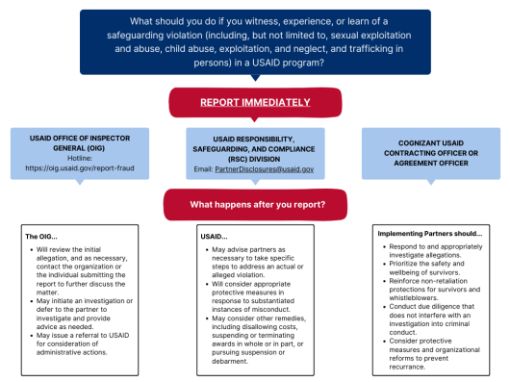
Note: This flowchart is for informational purposes only. Implementing partners should always look to the terms and conditions of their awards and follow supplementary Agency guidance.

An organization may have limited details regarding the allegation, but a timely notification allows USAID to work in partnership with the organization to address the incident.
Note: When reporting an allegation, the person reporting does not have to specify the category into which the conduct falls. When in doubt, report!
The following should be included in the report:
Award Information:
- Award title and number
- Organization name and sub-awardee name, if applicable
- Location of the program.

Incident/Allegation Details:
Who: Indicate who is involved (do not include the personally identifiable information of individuals)
- Is the survivor(s) a program participant/beneficiary/affected population?
- Are minors involved?
- Is the alleged perpetrator a senior leader?

What: Type of allegation(s), which may include:
- Sexual exploitation and abuse
- Child exploitation, abuse, and neglect
- Trafficking in persons
- Workplace misconduct.

Where: Country, Region, Program Sector
When: Date of the incident, date of the report to the organization
Response:
- Identify any actions taken or next steps to respond to the incident.
- Survivor support: resources available or provided to the survivor, steps taken to ensure the safety of the survivor(s) or whistleblower(s).
- Investigation status.
- Any established organizational procedures or framework to respond to the relevant type of misconduct.
- Interim measures or final measures taken or planned to address the alleged perpetrator.
- Any protective measures or organizational reforms, such as changes to applicable policies and procedures.

For more information on reporting potential safeguarding violations, please go to Section 3.2: More links to additional useful resources and follow the link to Safeguarding at USAID.

- Resource Mapping for Safeguarding
Resource Mapping provides important information to support reporting and responding to safeguarding concerns, by gathering information on contact points for safeguarding complemented by mapping exercises at the local level. Resource mapping aids identification of partner staff trained to work with victims and survivors and/or carry out investigations as needed. Due to the dynamic nature of stakeholders, it is crucial to ensure regularly updated information, at least once a year. This practice is essential as stakeholders' roles can evolve, necessitating accurate and current information to effectively address needs and expectations. This example shows how to organize information.

Organization
Country:
Address:
Responsible Person:
Contact Person:
Date of Last Update:

Police
(National) Emergency Telephone Number:
The Nearest Police Station:
Contact Person:
Address:
Telephone / Fax of Nearest Police Station:
Email:
References / Links:
How to Access the Service:

Legal Support / Advice
Name of Contact Person / Agency / Institution Supporting PCF in Legal Matters:
Address:
Telephone / Fax
Email:
References / Links:
How to Access the Service:

Health
(National) Health Emergency Number:
The Nearest Hospital / Medical Clinic:
Contact Person:
Address:
Telephone / Fax of Nearest Hospital
/ Medical Clinic:
Email:
References / Links:
How to Access the Service:

Social Services
Agency:
Address:
Contact Person:
Telephone / Fax:
Email:
References / Links:
How to Access the Service:

Family Counseling
Agency:
Address:
Contact Person:
Telephone / Fax:
Email:
References / Links:
How to Access the Service:

Reception Centre for Child Victims of Abuse
Agency:
Address:
Contact Person:
Contact Person:
Telephone / Fax:
Email:
References / Links:
How to Access the Service:

(Child) Safeguarding Focal Point of Operational Partner Organizations
Operational Partner Organization 1:
(Child) Safeguarding Focal Point:
Address:
Telephone / Fax:
Email:
Operational Partner Organization 2:
(Child) Safeguarding Focal Point:
Address:
Telephone / Fax:
Email:

Multiple actors form a comprehensive, multisectoral VAC response, and a referral process can enhance rapid access to multiple services, so that the child or adolescent does not ‘fall through the cracks’ and get lost to the system. A strong VAC referral system is a necessity for enabling a child or adolescent to receive comprehensive services from different people who have different skills. Having a functioning and well-coordinated referral process can reduce stress and workload for individual site/community staff member. The Office of HIV/AIDS in USAID/Washington has developed the following resource mapping framework.
Need | Name of agency and contact person | Contact | Responsible for follow-up
Family protection unit/social worker |  | Phone:  Email:
Counselling/crisis centre |  | Phone:  Email:
Support groups |  | Phone:  Email:
Mental health care |  | Phone:  Email:
Reproductive health care |  | Phone:  Email:
Laboratory services |  | Phone:  Email:
Child protection |  | Phone:  Email:
Education/school |  | Phone:  Email:
Police |  | Phone:  Email:
Forensics |  | Phone:  Email:
Shelter/housing/foster care |  | Phone:  Email:
Financial aid |  | Phone:  Email:
Legal aid |  | Phone:  Email:
Other |  | Phone:  Email:

Section 1: Communication with Children
Communicating with children regarding abuse and safeguarding builds their understanding of what is acceptable and what is not acceptable, recognize right from wrong and have expectations towards adults’ attitude. Children should be made aware of their right to be safe from abuse and should be provided with information, advice and support that is suitable for their age and developmental level. This includes what is harm and abuse, where and how to report safeguarding concerns, who to report to and where to find support.
Complaints mechanisms and safeguarding monitoring measures should be developed locally and in consultation with children, caregivers, and communities to ensure they are relevant, confidential and child friendly.

Section 1.1: Child Participation
Child Participation is the process in which children and young people become actively involved in identifying and solving problems they find in their living environment to improve the health and wellbeing of themselves and others. Children have the right to participate in matters that affect their lives. Participation is one of the four key principles in the UNCRC: survival, development, protection, and participation, with Article 12 the most significant for participation. Effective participation gives children opportunities to express their views in a format they choose; adults have a responsibility to listen to and consider children’s views when decisions are being made that affect them.
The design, development and delivery of programs must include discussion with children and communities regarding possible child safeguarding risks and the most appropriate measures to address these.
Child participation in child safeguarding is a particularly sensitive topic. Asking children to become involved in safeguarding may present unique problems but also unique opportunities. It is worth remembering for example, that children themselves can be a barrier to participation if they adopt harmful behaviors among adults, such as bullying, harassment, or imitating the use of coercive control to harm other children. However, when participation works effectively results are significant. It is best to work with children in their own settings rather than bringing them in to an unfamiliar environment. Those facilitating participatory work should ideally be those with direct experience of working with the children and trusting relationships should already exist.
Other barriers include adults who are willing to facilitate child participation but at some level lack the skills or attitudes to do so effectively. Adults need to be honest with themselves about their own cultural assumptions around the ability of young people to participate fully. This is because effective child participation challenges many commonly held ideas about adult-child relationships. Changing systems and mind-sets is where the real challenge often lies. Openness and honesty around these issues can go a long way towards ensuring that child participation is meaningful and not tokenistic.
Children’s participation requires building more in-depth, trusting relationships between adult workers, children and their families, communities, and schools, which can make children more at risk of abuse or threats of abuse. People who abuse children are often in positions of authority such as family members, teachers, or community leaders. They can also be other children.
Child participation should enable all children to share their views, regardless of gender, age, and ability. For participation to be successful, adult workers must ensure that children have the knowledge and skills to participate and the motivation to do so. You may need support from other people – including organizational management and staff – to create an enabling, positive learning environment.
There are four elements to the successful participation of children:
- Children understand what they are being invited to participate in through clear information.
- Children develop skills such as active listening, asking open thought-provoking questions and relating well to each other.
- Children feel motivated to participate
- An enabling environment. This means that children are respected by adults and they are given the support and opportunities they need to participate. There is also a safe space to do so and the involvement of people they trust.

Section 1.2: Core principles of communication with children
Facilitators must plan for and anticipate situations that might present risk. Although it may be fair to assume that the children that have agreed to participate in activities are willing to speak about their circumstances and their experiences, it is inevitable that they will have some anxieties about this. Because of their experiences at the hands of adults, their levels of trust may be severely diminished. Children that have been abused and exploited have often felt powerless in their interactions with adults, so giving the child some control over proceedings and consulting them on how the process will go, even just minor things such as seating arrangements, when to take a break, and so on, will also go a long way to demonstrating respect and concern for their safety and well being.
The following ethical principles and safeguarding considerations represent a good starting point for planning and should inform ongoing activity.

Best interest of the Child
All communications with and regarding children must be conducted in a way to ensure that the best interests of children and safety are of paramount importance.

Safe Environment
Communication with children should be held in places where they feel comfortable – child-friendly and appropriate for the child’s age. A neutral venue they are familiar with and safe in will help in putting them at their ease, rather than a place where they are visible to others in the community entering and leaving. Ensure that another adult is present when working in the proximity of children. Careful advance planning is crucial. Only begin the activity if services are in place to address possible consequences.
If the communication activity is not associated with a service, prepare referral information for children to reach the required support. Do not conduct the activity without functional support systems in place.

Privacy and Confidentiality
Prepare to explain confidentiality and the limits to confidentiality; it may be helpful to warn the interviewees that it is possible the police could subpoena the notes of the interview if they became relevant to any criminal prosecution. Information received from the communication must only be disclosed to a limited number of specified people on a need-to-know basis. Arrangements should be made for secure transfer and storing of information. Plan to respond to any accidental disclosure of information. Below is a sample script.

Sample script 1

Confidentiality is a bit like having a secret, but with some important rules to keep everyone safe. It means that when we talk about things or share information with someone, we promise to keep it private and not tell anyone else, unless there's a really good reason. When we talk about limits to confidentiality, it means that sometimes, even though we promised to keep things private, there are special situations where we might need to share that information with certain people. For example, if someone's safety or well-being is at risk, or if it's something that the law says we have to tell someone about, like the police.
One thing to remember is that if the police need information and they think it's really important for solving a crime or keeping people safe, they might ask for the notes from our conversation. They would do this by something called a subpoena, which is like a special permission slip. So, while we do our best to keep things private, there are times when the police might need to see what we talked about.
However, we always make sure that we only share the information with a small number of specific people who really need to know it. We also take extra care to make sure the information is kept safe and secure, so nobody else can see it. We have special arrangements in place for transferring and storing the information securely.
Sometimes, accidents happen, and information might accidentally get shared with someone who wasn't supposed to know. If that happens, we have a plan in place to respond to it and make things right. We understand that mistakes can happen, and we work hard to fix them and protect everyone's privacy.
So, remember, confidentiality means keeping things private and not telling anyone unless we have a good reason. But in certain situations, like if someone's safety is at risk or if the law requires it, we might have to share the information with specific people. We take precautions to keep the information safe and have plans in place if any mistakes occur.
c

Sample script 2
The only exception to me sharing your confidential information is if you directly tell me that someone is hurting you, that you plan to hurt yourself or someone else, or that you are immediate danger. If you are in immediate danger, then I will have to tell a trained social worker [or insert other required person/organization] so we can get you help.

Participation and Informed Consent
A full explanation should be given to all participants or potential participants both in advance of requesting their participation (where possible) and again at the time of participation. Assent may be verbal. In such cases, the verbal assent should be recorded in case notes, stating how this was provided, and kept on file. Written and verbal explanation should be provided to include details of:
- the activity itself – why it is taking place, who is conducting it, what it hopes to achieve.
- the adults – who they are, where they are from
- the process – what will happen, where, who will be present.
- the outputs – what will happen to the information disclosed by children, how will this be recorded, kept, accessed, disseminated.
- safety and support – the risks involved and the commitments to keep respondents safe and to assist them as far as possible/as required.
‘Informed consent is the voluntary agreement of an individual, adult or child, who has the capacity to give consent, and who exercises free and informed choice. This means that they have been given necessary information and have the right to refuse treatment. This also has legal implications related to the age of consent.

Informed assent is used when a child is too young to give informed consent based upon their legal age of consent for medical procedures but is old enough to understand and agree to participate in services.’
Guiding Principles for Working with Children and Adolescents at Risk of or Survivors of VAC

Professional Duty and Care
People communicating professionally with children should be competent, responsible, independent, suitably qualified and trained. They are responsible for thinking through all possible consequences (intentional and unintentional, see below) and for anticipating the effect of the activity on young people and their families.
For example, adults working with children may be subject to legal codes governing their behavior, including those of the country of the organization managing the activity, the country funding the activity, and the country where the activity is taking place. By proactively thinking through these potential consequences, professionals can ensure their communication is respectful, supportive, and beneficial for children. Consequences may include:
- Emotional Impact: The way professionals communicate with children can have emotional consequences. For example, using harsh or inappropriate language may cause the child to feel upset, embarrassed, or discouraged. On the other hand, positive and supportive communication can enhance a child's self-esteem and emotional well-being.
- Trust and Relationship Building: Communication plays a crucial role in building trust and positive relationships with children. If professionals fail to communicate effectively or break promises, it can lead to a breakdown of trust and strain the relationship between the child and the professional.
- Information Privacy: Sharing confidential information without consent or inappropriately can breach the child's privacy. Professionals must ensure that they handle sensitive information appropriately and only share it with authorized individuals or agencies when necessary.
- Empowerment and Participation: Professionals should consider the potential impact on a child's sense of empowerment and participation. If they dismiss or ignore the child's opinions, ideas, or preferences, it can discourage their engagement and hinder their development of decision-making skills.
- Safety and Well-being: Professionals communicating with children need to anticipate the potential consequences for the child's safety and well-being. They must assess whether their communication could inadvertently put the child at risk or expose them to harm.
- Family Dynamics: Professionals should be aware of the potential effects their communication may have on the child's family. For instance, discussing sensitive topics without considering the family's circumstances or cultural context could create tension or strain within the family unit.
- Long-Term Impact: Communication experiences with professionals can have lasting effects on a child's perception of authority figures, their willingness to seek help, and their overall outlook on education or support systems. Professionals should be mindful of the long-term impact their communication can have on a child's development and well-being.
Anyone who is involved in Violence Against Children (VAC) case identification should be trained in first-line support (LIVES CC) and prepared to respond using the LIVES CC approach including referrals and additional support as appropriate. For disclosures directly from children, it is important to listen to the information being shared but not press for further information; ask open questions, and only enough questions to obtain information to refer to qualified child safeguarding professionals.

Appropriateness
Communications with children should consider culture, age, race, ethnicity, religion, gender, sexuality, and special needs. The below examples show how communication can be tailored.
- Cultural Appropriateness:
- Language and Terminology: Professionals should be mindful of cultural nuances and avoid using terms or expressions that may be unfamiliar or offensive.
- Respect for Cultural Practices: Professionals should be open to understanding and incorporating cultural perspectives into their communication, while avoiding judgments or biases based on cultural differences.
- Non-verbal Communication: Different cultures may have varying norms regarding non-verbal communication. Professionals should be aware of these differences and adapt their non-verbal cues, such as eye contact, gestures, and personal space, to align with the child's cultural expectations.
- Inclusive Examples and References: Professionals should strive to use diverse cultural contexts, stories, and role models to which children can relate.
Professional: Hi there! I wanted to talk to you about something very important called ‘staying safe’. Do you know what it means to stay safe?

Child: Um, I think it means not getting hurt or being in danger.

Professional: That's right! Staying safe means taking steps to protect ourselves and prevent harm. Now, there are some things we should know to keep ourselves safe, and it's important for everyone, no matter where they're from. Would you like to learn some ways to stay safe?

Child: Yes, please!

Professional: Great! One important thing is to always trust your feelings or instincts.
If something feels wrong or uncomfortable, it's okay to say ‘no’ or get help from a trusted adult. Another way to stay safe is to know your personal boundaries. That means understanding what is okay and not okay for others to do to your body.
Professional: Exactly! It's important to remember that your body is your own, and you have the right to say ‘no’ if someone tries to touch you in a way that makes you uncomfortable, even if they say it is normal. You can talk to a grown-up you trust, like a parent, teacher, or another adult, if this ever happens.

Child: Okay, I understand.

Child: Like when someone touches me in a way I don't like?

Professional: Remember, it's important to talk to someone you trust if anything ever makes you feel worried or unsafe. They can help you stay safe and make sure you're protected. Do you have any questions or anything else you'd like to know about staying safe?

Child: No, I think I understand. Thank you for talking to me about this.

Professional: You're very welcome! It's important for us to have these conversations so that you can be safe and feel secure. If you ever need to talk about anything or have more questions, don't hesitate to reach out to me or another trusted adult.

- Age Appropriateness:
- Language and Vocabulary: Professionals should use language and vocabulary that is appropriate for the child's developmental level. They should avoid using complex or technical terms that may be difficult for the child to understand. Instead, they should use simple and clear language that matches the child's cognitive abilities. See Section 2 below for examples.
- Visual and Interactive Materials: Younger children often respond well to visual aids, storytelling, and interactive materials. Professionals can use age-appropriate visuals, such as pictures, drawings, or videos, to enhance understanding and engagement during communication. See Section 1.3: How to speak with children about abuse and safeguarding and Section 2.2: Guide to developing your child-friendly reporting and responding mechanisms.
- Communication Style: Professionals should adapt their communication style to match the child's age. For example, when communicating with younger children, they may use playful and engaging approaches, while older children may benefit from more structured and informative discussions. See Section 2 for examples.
- Conceptual Understanding: Professionals should assess the child's level of understanding and tailor their explanations accordingly. They should break down complex concepts into simpler, relatable terms that the child can grasp and relate to their own experiences. See Section 2 for examples.
- Respect for Autonomy: As children grow older, it is important to involve them in decision-making and provide opportunities for their input and participation. Professionals should respect the growing autonomy of older children and engage in dialogues that allow them to express their opinions and preferences.

Age appropriateness developmental guidelines
Age | Colors | Messages
2 - 6 | Primary colors  and basic shapes. | One simple concept message per illustration.
7 - 10 | Primary and secondary colors with more  complex shapes. | Can accommodate two concept messages in an illustration.
11 - 14 | Full range of colors  and shapes. | More than three messages per illustration.
15 - 18 | Full range of colors  and shapes. | Greater use of text mindful of the literacy level  of the local context.

Section 1.3: How to speak with children about abuse and safeguarding
Often adults fear that children cannot handle information about abuse and feel uncomfortable communicating about abuse with children, and this can be reinforced by local contexts, cultural beliefs, and stigma around harm and abuse. Organizations operating in such conditions find it challenging to recognize the issue and set up proper reporting and responding mechanisms.
However, not communicating with children about abuse and child safeguarding risks continuing the culture of stigma. Organizations need to ensure that they are not reinforcing bad practices, but they also need to be careful when discussing issues of abuse and safeguarding.
You need to make sure that you can explain to children what is abuse and what is safeguarding, and what to expect from staff and programs. This includes what is appropriate and inappropriate adult behavior and where, how and to whom children can report their concerns if they experience or see abuse or harm caused by the representatives of the organizations. The language should be understandable to children because they deserve to know their rights even through some terms and definitions might be hard to understand. Use a child-friendly tone and age-appropriate wording.

Child Friendly Term Explanations

Child - Every human being below the age of 18 years old.
Children’s rights - Children’s rights are promises that governments made so children can have a good life. Children have a special set of rights in the United Nations Convention on the Rights of the Child – the UNCRC.

Human rights - These are the rights all people have. They make sure that everyone is treated the same and with respect.
Non-governmental organization (NGO) - A non-governmental organization is a group like a charity that helps children or others or campaigns for good causes, like defending children’s rights or fighting climate change.
Child participation - This is when children are allowed to say what they think about things and adults have agreed to listen.
Safeguarding Policy - A plan by the government of a country (or the governments of several countries), or an organization, to do something good or stop something bad happening to children.
Safe from harm - Children will be kept safe from violence and children who are harmed will get the help they need.
United Nations (UN) - The United Nations (UN) is made up of 193 countries from across the world. Its role is to help these countries to keep their human rights promises.
UNCRC - This is the world’s biggest set of promises about children’s rights. These are strong promises made by governments to make sure that children lead a good life.
Article 2 UNCRC - All children have these rights, no matter who they are, where they live, what language they speak, what their religion is, what they think, what they look like, if they are a boy or girl, if they have a disability, if they are rich or poor, and no matter who their families are or what their parents or families believe or do. No child should be treated unfairly for any reason.
Article 19 UNCRC - Governments must protect children from violence, abuse and being neglected by anyone who looks after them.
Article 34 UNCRC - Nobody should touch me in ways that make me feel uncomfortable, unsafe, or sad. Article 34 of the UNCRC says that children and young people have the right to be protected from sexual abuse.
Article 35 UNCRC - I should not be abducted, sold or trafficked. Article 35 of the UNCRC makes it clear that abducting, selling or trafficking children or young people is always wrong.

Child Abuse
Explaining harm and abuse to children, especially sexual abuse could be challenging. Sometimes, depending on their age, they could find it hard to understand. It helps to be friendly and approachable and always consider the core principles of communication with children. A good way to start the discussion is to use a story that is suitable for the age group. One good example to involve children in discussions on safeguarding risks would be drawing a body or using a doll.

Abuse is when someone does something to hurt you or fails to do something, and this leads to you being hurt.

You can list the main categories of abuse: physical abuse, sexual abuse, sexual exploitation, neglect, and emotional abuse, and explain them as follows:

Physical Abuse
Sometimes, children can experience things that hurt their bodies when someone else, like a grown-up or another child, does something that causes harm. Some examples of this include hitting, shaking, giving harmful things to eat or drink, making them go underwater when they can't swim, or making them touch something hot that can burn them. It can also happen when a parent or caregiver pretends that a child is sick or makes them sick on purpose.

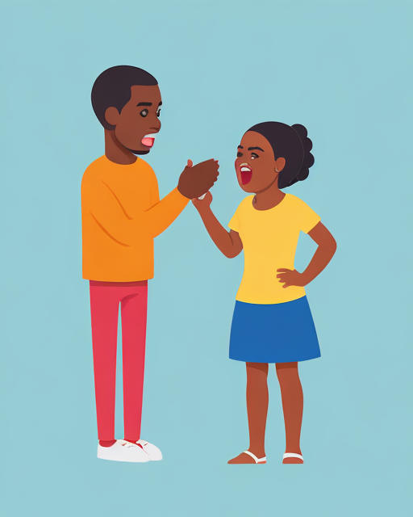
Support this with a drawing of an adult reaching towards a child.

Sexual Abuse
Support this with a drawing of a monster-like creature hovering over a child.
Sexual abuse is when someone does things to your body that are not right or okay. It can happen when someone touches your private parts in a way that makes you feel uncomfortable, scared, or confused. Private parts are the areas covered by your swimsuit, like your chest, bottom, or the area between your legs. Sexual abuse can also happen if someone asks you to touch their private parts or makes you do things that you don't want to do. Remember, your body is yours, and you have the right to decide who can touch it. Nobody should ever make you feel uncomfortable or do things that you don't want to do.

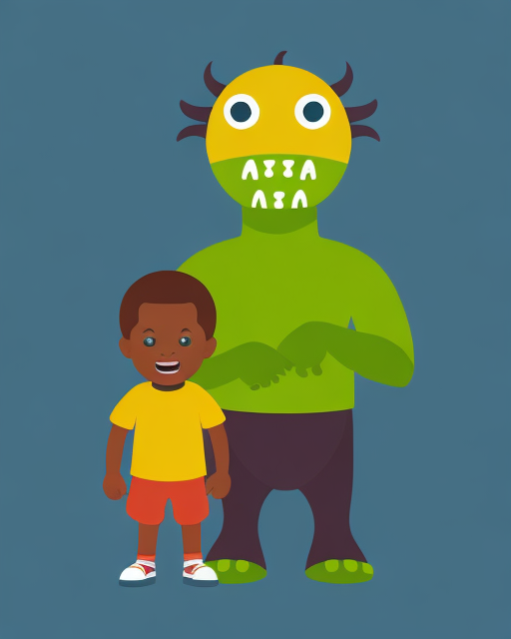

Child Sexual Exploitation
Neglect or Negligent Treatment
Child sexual exploitation is when someone tries to take advantage of you or use you in a wrong way that involves sexual things. It's like when a person tricks or forces a child into doing things that are not okay and make you feel scared or uncomfortable. Sometimes, people who do this might try to be your friend or give you presents to make you trust them. They might ask you to do things that you don't understand or that are not right for your age. This can happen online or offline.
Neglect or negligent treatment happens when grown-ups don't give children the love and care they need. It means the adults aren't taking care of the child properly, which can make the child feel sad, scared, or lonely. Sometimes, neglect can mean not having enough food to eat or not having clean clothes to wear. It can also mean that the child doesn't have a safe place to live or isn't getting the right medical care when they're sick. Neglect can also happen when carers don't spend time with them or don't listen to them.

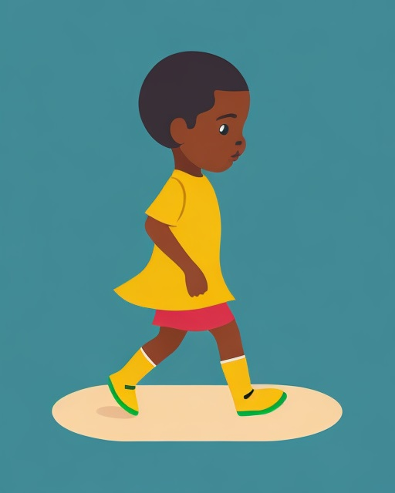
Support this with a drawing of adults ignoring a child or a drawing of a sad child.

Emotional Abuse
Emotional abuse is when someone says or does things that hurt your feelings a lot. It's like when they use mean words or yell at you all the time, making you feel scared, sad, or like you're not good enough. Emotional abuse can also happen when someone constantly ignores you or doesn't show you love and support. They might make you feel like you're not important or don't matter. Sometimes, emotional abuse can make you feel confused or like it's your fault, but it's important to know that it's never your fault. Everyone deserves to be treated with kindness, respect, and love.

Support this with a drawing of an adult speaking angrily to a child.

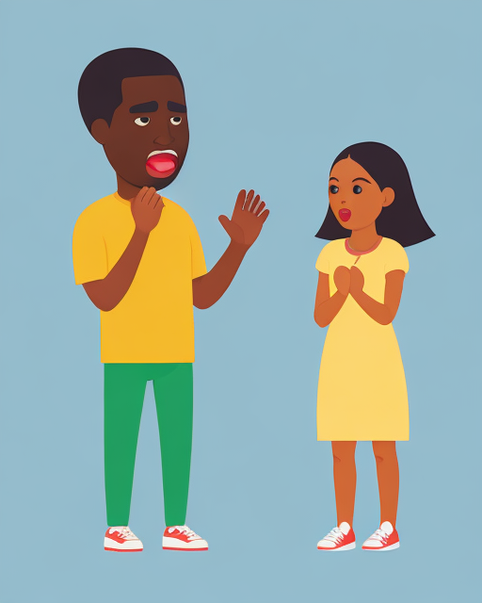

Child Safeguarding
Children would be curious to know who you are and why you would like to speak with them.
You can introduce your organization, explain what your organization does, and make your organization’s commitment clear. It is important that children understand as much as they can about the topic of safeguarding. The adult worker can teach children about the topic through practical activities, role play and games, and by making up or telling stories that link to the topic or by drawing or discussing relevant pictures. Develop your skills by remembering to ask for feedback from children after each explanation on what they understood.
I want to tell you about our organization that is called [Organization Name]. We help children in need or going through difficult times. Some kids don’t have enough food or clothes. Also, we help kids who don’t have homes or can’t go to school.
We have kind and caring people who come together to help children who need support. We collect donations like money, clothes, or toys from kind-hearted people, and then use them to help those in need. Sometimes we also organize events or programs to gather support.
We want to make sure that all our people are kind, treat you well and do not harm you. It’s called child safeguarding, and it means we want to keep you safe. It's all about making sure that you are in a safe and happy environment.
We have trained our staff, so they understand how to keep you safe and what to do if they are concerned about you.

Section 1.4: First-Line support for children and adolescents at risk of or experiencing violence
Mandatory reporting in cases of abuse is not the same thing as referring a child or adolescent for immediate protection if they are in imminent danger. If a child or adolescent is in imminent danger, first, take action to enhance safety and facilitate support through referral to local police and/or child protection services. Then report to the designated mandatory reporting agencies as per your country’s national guidelines and your site’s mandatory reporting standing operational procedures. Remember to follow the principles for mandatory reporting, including explaining to the child or adolescent the limits of confidentiality (see Section 1.2: Core principles of communication with children: Privacy and confidentiality).
First-line support and violence case identification are not the same – first-line support is the immediate response to disclosure or suspicion of violence. First-line support is one of the most important elements of care to survivors of violence and is based on psychological first aid – it should be offered immediately after violence is disclosed or suspected. As a practical, survivor and child-centered, empathetic approach to responding to survivors of violence, in some cases first-line support may be the only care possible in the absence of other health services. It responds to a child’s emotional, safety, and support needs, while respecting their privacy, and may be provided to both the child or adolescent and their non-offending caregiver. First-line support is also provided to adult survivors of violence using the LIVES CC approach.
Violence case identification involves using routine or clinical enquiry to identify those who have experienced or are experiencing violence. Site/program staff should not conduct violence case identification if they are not trained on providing age-appropriate first-line support. If violence is disclosed or suspected, first-line support should always be provided. LIVES and LIVES CC are the approach used to respond if violence is disclosed or suspected. Although a program staff member may not conduct violence case identification, a client may still disclose experience of violence to them. As such, program staff should be prepared to provide first-line support using LIVES or LIVES CC even if they are not actively identifying survivors in their facility- or community-based work.
For the purpose of this toolkit, we will be looking only into LIVES’ first three elements.

Listen | Listen closely with empathy and without judging in  a private space.
Inquire | Assess and respond to the survivor’s needs and concerns – emotional, physical, social, and practical.
Validate | Show that you believe and understand the child or adolescent and that they are not to blame for what happened.
Enhance Safety | Protect child or adolescent from further harm.
Support | Connect the child or adolescent to formal or informal  support services.
Child and Adolescent Friendly Environment | Create a child and adolescent friendly environment by training program staff/volunteers and improving service readiness to provide survivor-centered care.
Caregiver Support | Provide support to non-offending caregivers to support the child or adolescent.
Listen closely with empathy and without judging in a private space, to learn what is most important to the child. Allow the child to choose who is in the room with them and then initiate a conversation about how the child feels and what they need. Stay silent if the child or caregiver does not immediately answer. As you listen:
Pay attention to what the child or adolescent says about their needs or concerns.
- Take note of the interaction between the caregiver and the child or adolescent.
- Pay attention to the body language of the child or adolescent and caregiver.
- Try to learn about the physical, emotional, or economic needs, safety concerns, or social support the child or adolescent might need.

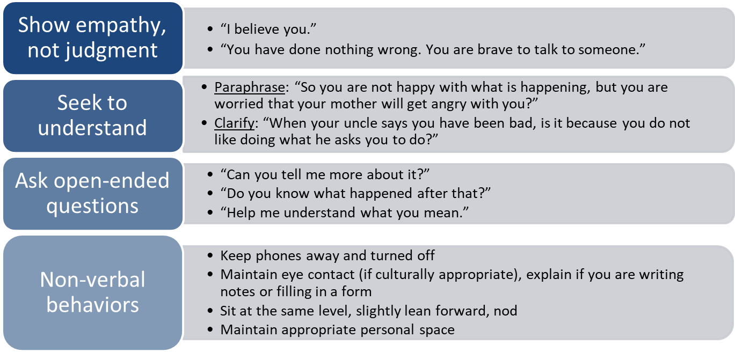

Do:
- Be patient and calm. Do not pressure the child or adolescent to talk.
- Let the child or adolescent know that you are listening (i.e., nod, say “hmm”).
- Be at the same physical level as the child. Be close enough to show concern, but not to make them feel uncomfortable.
- Acknowledge how the child or adolescent is feeling.
- Let the child or adolescent choose how to express themselves (i.e., drawing, writing, showing).

- Ask open-ended questions instead of “yes” or “no” questions.
- Reflect the feelings of the child or adolescent and pay attention to nonverbal cues and body language.
- Address the child or adolescent directly.
- Allow for silence. Given the child or adolescent time to think.

Don’t:
- Don’t look at your watch, answer your phone, look at your computer, or write.
- Don’t speak too quickly.
- Don’t speak condescendingly to the child.
- Don’t assume that you already know what is best for the child.
- Don’t talk with the caregiver about the child or adolescent in the third person.
- Don’t interrupt or ask questions before the child or adolescent has finished speaking.
- Don’t try to finish the thoughts for the child, adolescent, or caregiver.
- Don’t tell the child or adolescent someone else’s story or how you interact with your own children.

Inquire by assessing and responding to the child’s needs, wishes, and concerns - emotional physical, social, and practical. The purpose is to ask about the child’s physical, emotional, and social support needs and any safety concerns; needs and concerns can also be raised by the non-offending caregiver. Inquiring is not a one-size-fits-all approach: how you inquire should be nuanced and based on the situation and the age and developmental stage of the child. Inquire does not mean asking about experience of violence, screening for violence, or conducting violence case identification, but rather means speaking with a child or adolescent to understand their physical, emotional, and social support needs for the purposes of responding to those needs through referrals.

Tips and Hints | Example of what to say
Phrase questions as invitations to speak. | “How can I help you today?”
Help the child or adolescent identify and express needs and concerns. | “Is there anything that you need or that you worry about?”
Explore as needed, without probing. | “Can you tell me a bit more about what you mean  when you say…”
Ask for clarification if you don’t understand. | “Can you explain that, please?”
Summarize and repeat what you understood, using the same words as the child.

Validate by showing the child or adolescent that you believe and understand them and that they are not to blame, to validate the experience of the child or adolescent by letting them know that their feelings are normal, that it is safe to express their feelings, and that they have a right to live without violence or fear. Let the child or adolescent know you are listening attentively, understand what they are saying, and believe them without judgment.
Words you can use to demonstrate understanding include:

- I believe you.
- This is not your fault. You are not to blame.
- I am very glad you told me.
- It’s ok to talk.
- I am sorry this happened to you.
- You are very brave for telling me.

Acknowledge that all of the feelings that child and adolescent survivors of violence are feeling are valid, including hopelessness, powerlessness and loss of control, guilt and shame, fear, and anger. Here are examples of things you can say to validate children and adolescents.

Feeling | Example of things you can say
Hopelessness | “Many children/adolescents feel what you’re feeling after such an experience. I’m here to help you and there are ways we can support you to feel better.”
Powerlessness and loss of control | “I will explain to you how we proceed today. You can also make some choices by yourself.”
Guilt and shame | “You are not to blame for what happened to you.  You are not responsible for his/her/their behavior.”
Fear | “Right now, you are in a safe place.”
Anger | “It’s OK to be angry.”

Section 2: Designing Child-friendly documents
Child-friendly documents promote the well-being, safety, and active participation of children within an organization. They are an important tool for ensuring effective communication, empowering children, and fostering a culture of child protection. Child-friendly documents are essential in organizations working with children for several important reasons.
Accessibility: Child-friendly documents are designed to be easily understood by children of different ages and reading abilities. By using simple language, engaging visuals, and age-appropriate content, these documents ensure that children can access and comprehend the information.

Empowerment: Child-friendly documents empower children by providing them with information about their rights, safety measures, and resources available to them. When children understand their rights and how to protect themselves and report concerns, they can actively participate in their own well-being and make informed decisions.

Inclusion: Child-friendly documents promote inclusion by considering diverse needs and backgrounds. They take into account factors such as language barriers, learning disabilities, or cultural differences, ensuring that all children can access the information and benefit from it.

Safeguarding: Child-friendly documents play a crucial role in educating children about potential risks, safety guidelines, and how to seek help if they feel unsafe. By providing clear and age-appropriate information, these documents empower children to recognize and respond to situations that may threaten their safety or well-being.

Communication and Transparency: Child-friendly documents facilitate open communication and transparency between children, parents, and the organization. They help establish a shared understanding of policies, procedures, and expectations, ensuring that everyone is on the same page and can actively participate in creating a safe and supportive environment for children.

Compliance and Accountability: Child-friendly documents demonstrate an organization's commitment to child safeguarding and adherence to legal and ethical guidelines. By providing clear information on policies, reporting mechanisms, and the responsibilities of staff and volunteers, these documents ensure accountability and support a culture of safeguarding within the organization.

When it comes to creating materials that are child-friendly, it is important to consider font size and colors that are visually appealing and easy to read.
Font Size: for younger children (ages 5-8), a font size of around 18-24 points is recommended for titles and headings, while the main body text can be around 14-18 points. For older children (ages 9-12), a slightly smaller font size can be used, such as 16-20 points for titles and headings, and 12-16 points for main body text.
Colors: Bright and vibrant colors are generally appealing to children. Consider using a mix of primary colors (such as red, yellow, and blue) or bold, contrasting colors. Avoid using overly saturated colors that may strain the eyes or make reading difficult. It's generally recommended to use a dark-colored text on a light-colored background for optimal readability. Consider using color combinations that are aesthetically pleasing and provide good contrast (e.g., black text on a white background or white text on a dark blue background).
Images: When selecting child-friendly images, it's important to choose visuals that are appropriate, engaging, and easy for children to comprehend. Use images that are bright, cheerful, and colorful. Bold and vibrant colors can help capture a child's attention and make the visuals more appealing.
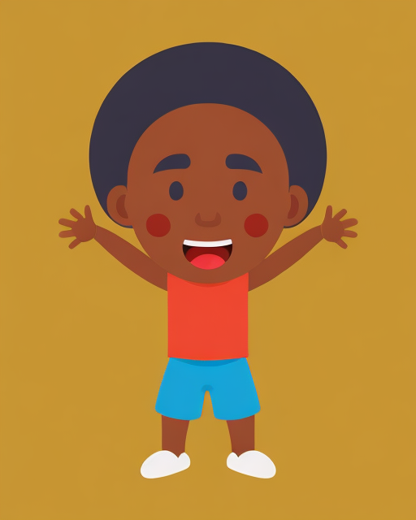

Select images that are age-appropriate and relevant to the child's interests. For example, images of animals, nature, or cartoons may be more engaging for younger children.
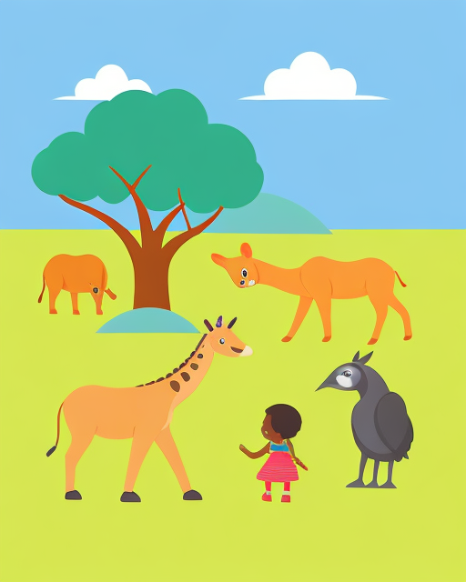

Use images that are clear, simple, and easy to understand. Complex visuals may be confusing and difficult for children to comprehend, so it's best to choose visuals that are straightforward and easy to interpret.
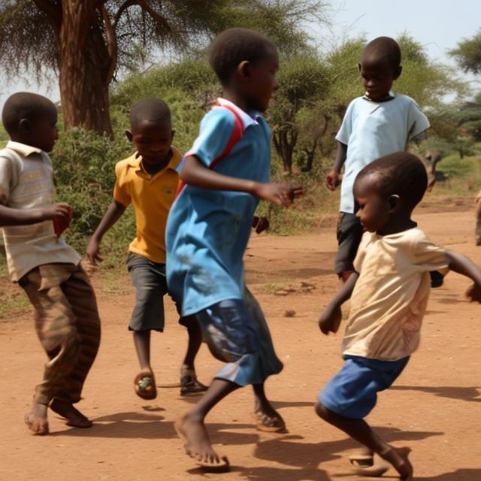
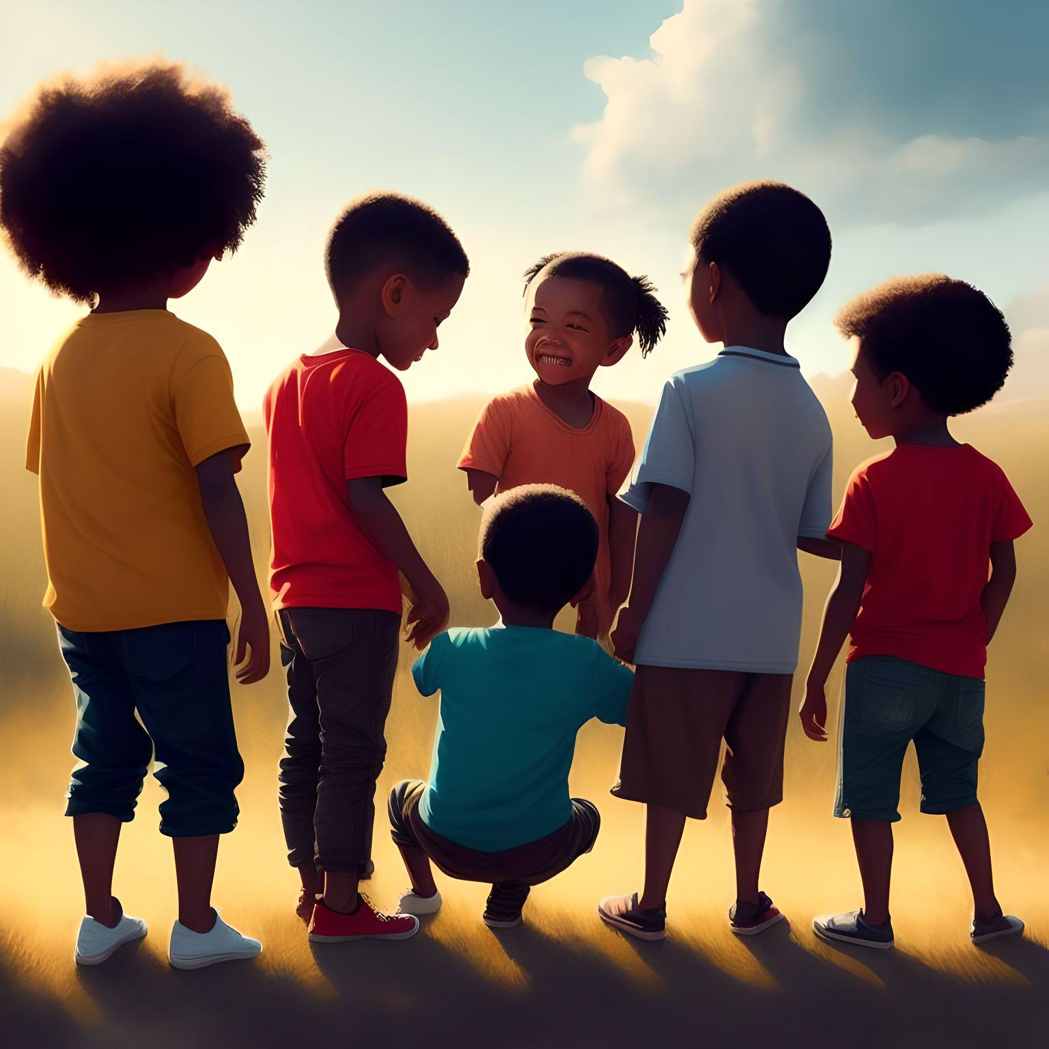

Avoid using images that may be frightening, disturbing, or inappropriate for children. This includes images of violence, gore, or sexual content, which may be harmful or upsetting for young viewers.
However, there are instances where tackling important and sensitive issues, such as sexual or physical abuse, becomes necessary to ensure the safety and protection of children. In such cases, age-appropriate and sensitive approaches should be taken. This might involve using carefully designed visuals and explanations that communicate the seriousness of the issue without causing unnecessary fear.
In summary, while frightening pictures should generally be avoided in child-friendly materials, exceptions can be made for addressing critical topics like sexual or physical abuse. In these cases, it's crucial to exercise great care and thoughtfulness in how such topics are presented, ensuring that the child's emotional well-being remains a top priority.
Consider using real-life photographs, illustrations, or cartoons that depict positive experiences and emotions. Images that convey happiness, friendship, and love can help promote positive emotional development in children.
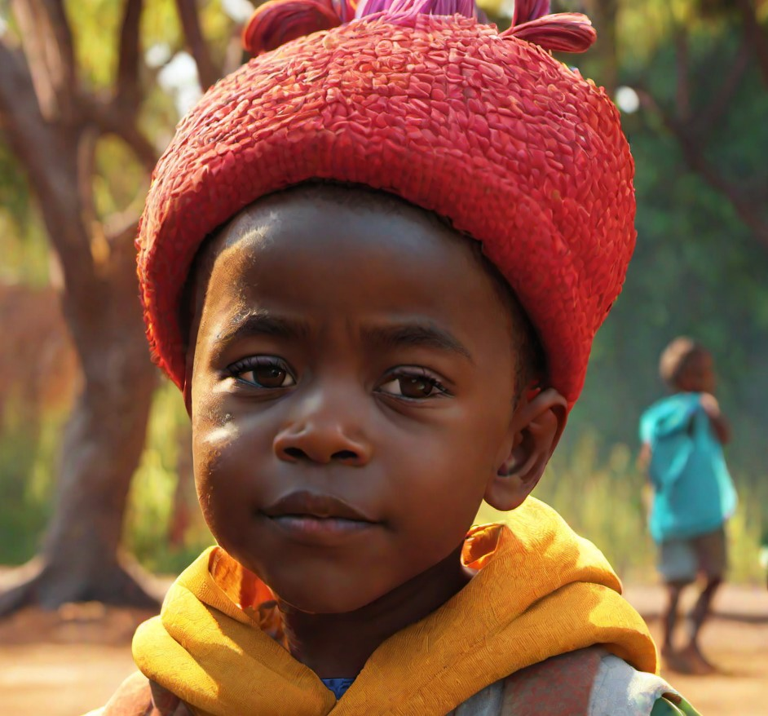

There are a variety of resources available online for finding child-friendly images, including free stock photo libraries and educational websites. Some popular resources include Pexels [1], Pixabay [2], and Getty Images [3]:
https://www.pexels.com/search/child%20friendly/
https://pixabay.com/images/search/child-friendly/
https://www.gettyimages.com/photos/kid-friendly
These websites offer a range of high-quality, age-appropriate images that are suitable for use in educational materials, presentations, and other child-focused applications.
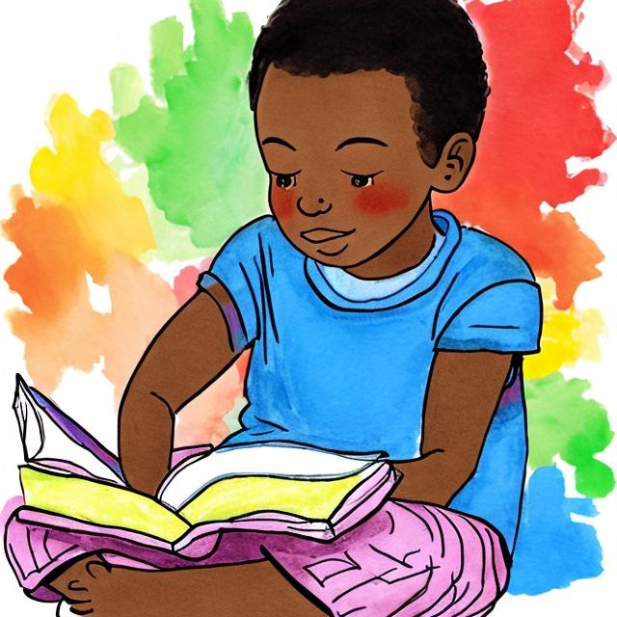
It's important to keep in mind that every child is different, and their preferences may vary. It can be helpful to involve children in the design process and gather their feedback on font sizes and colors to ensure that the materials are truly child friendly.

Before you start designing your child-friendly documents, make sure you read the Lundy model of child participation, which outlines the principles and recommendations of Professor Laura Lundy, an expert in children's rights and participation. Her guidance serves as a valuable resource for understanding and promoting children's rights and their meaningful participation in decision-making processes.
The European Commission’s guidance on creating child-friendly documents is another useful resource that offers templates for policies and procedures.

Section 2.1: Developing a child-friendly version of your child safeguarding policy
A child-friendly child safeguarding policy is a summary version of the document described in Standard 1, using language and visuals appropriate for children. Creating a child-friendly version of a child safeguarding policy involves simplifying and presenting the policy in a way that is easy for children to understand. Designing a child-friendly policy involves considering the needs, interests, and understanding of children. When developing your child-friendly policy you should consider age, ability, culture, gender, race, ethnicity, and special needs; you might need to develop more than just one child-friendly version to accommodate these specifics. Here are some steps to help you create a child-friendly version:
- Define the purpose and scope of the document. Identify the key information or messages you want to convey to children.
- Understand and summarize the original policy. Start by thoroughly reviewing the original child safeguarding policy to understand its key components, guidelines, and procedures. Identify the essential information that needs to be communicated, core elements that children should be aware of for their safety – the code of conduct and the reporting and responding mechanism.
- Create your first child-friendly policy draft. Organize the information and structure the document in a logical and organized manner by using headings, subheadings, and bullet points to break down the content into manageable sections. This helps children navigate through the document and locate information easily.
- Use child-friendly language. Choose simple and age-appropriate language that children can easily understand, use clear and concise wording to convey your message effectively, and avoid using jargon, technical terms, or complex sentences. Aim for the reading and comprehension level of a child aged 11-13 years. Use readability checkers and tests.
- Incorporate visuals such as illustrations, pictures, or icons to make the document visually appealing, reinforce the message, clarify concepts, and enhance comprehension for children.
- Use examples and stories to help children understand and relate to the information. Real-life scenarios or fictional characters can make the content more memorable for children.
- Provide supportive resources such as helpline numbers, websites, or contacts of designated focal points that children can refer to for further support or information.
- Seek feedback and consult with children. Before finalizing the document, gather feedback from children and child-focused professionals. Their input can help ensure the document is clear, engaging, and effectively communicates the intended message.
- Regularly review and revise the document to ensure it remains up-to-date, relevant, and aligned with the needs of the children it serves.
It is essential to take an approach that is contextual and culturally appropriate. The above steps define a framework for action but are not a recipe of identical steps to be applied in every context. See Section 3.1: Templates, C: Child-friendly child safeguarding policy and reporting procedure template.

Section 2.2: Guide to developing your child-friendly reporting and responding mechanism
Children should be provided with information on where to go to for help and advice in relation to abuse, harassment, and bullying. They need to know how to raise a concern with the organization and feel confident about it. If you already have a reporting mechanism, you need to make sure that children are aware how to use it and support them to feel comfortable using it. You can use the following messages to start a discussion with children around reporting different types of abuse or incorporate them in your child-friendly reporting procedures.
If someone ever tries to do something that makes you feel strange or scared, it's important to talk to a trusted adult, a grown-up you feel safe with. They will help protect you and make sure you stay safe. It's important to know that this is never your fault.

Remember, it's okay to say "no" to anything that feels wrong or uncomfortable. You have the right to be safe, and there are people who will listen to you, believe you, and help you stay protected.

Remember, it's okay to say "no" to anything that feels wrong or uncomfortable. You have the right to be safe, and there are people who will listen to you, believe you, and help you stay protected.

Sometimes, people who do bad things might try to keep it a secret or tell you not to tell anyone. But it's important to remember that you have the right to speak up and get help. You can talk to a grown-up you trust, who will listen to you, believe you, and help keep you safe.

If you ever feel like you're not getting the care and attention you need, or if you see someone else who might be going through this, it's important to talk to a trusted adult you feel safe with. They can help make things better and make sure you get the love and care you deserve. Remember, every child deserves to be safe, loved, and taken care of.

There are some important things to remember to keep safe:
Listen to your feelings: If something feels wrong or makes you uncomfortable, it's important to tell a grown-up you trust. They are there to help you.
Know your rights: Your body belongs to you, and you have the right to decide who can touch it. No one should ever touch you in a way that makes you feel uncomfortable or scared.
Share your worries: If you have any worries or concerns, don't keep them to yourself. Talk to a trusted adult, like your parents, teachers, or another grown-up you feel safe with. They are there to help and protect you.
Stay safe online: When using the internet or social media, it's important to be careful. Don't share personal information or talk to strangers online. If something or someone online makes you feel uncomfortable, tell a grown-up right away.

There are people who work together to keep children safe. Many grown-ups have an important role in protecting children. They want to make sure that children are healthy, loved, and free from harm.
Child safeguarding also means that if a child ever feels scared, uncomfortable, or if something bad happens to them, there are adults they can trust and talk to. These trusted adults will listen, believe, and help them stay safe.
Remember, child safeguarding is all about making sure that you and other children are safe, happy, and protected. It's okay to ask for help, and there are people who care about you and will do everything they can to keep you safe.

Here is a brief step-by-step guide on how to set up a child-friendly reporting and responding mechanism:
Step 1: Carry out risk assessment
Go back and read again the section on the International Child Safeguarding Standards, Standard 3: Procedures. Map out your organization’s contacts with children. Identify the different ways in which your organization comes into contact with children even when they may not be the primary focus. Identify who in your organization has contact with, access to or impacts on children.
Consider ways in which your organization has contact, access, or impact on children, such as the organization’s programs, people, and operations.
- Programs: the services, activities that are delivered by the organization
- People: staff, volunteers, partners, consultants, contractors, or other associates that are engaged with the organization
- Operations:
- What type of communications involve children and/or vulnerable adults and how? Their stories and images.
- What information on children is held by the organization? Where? Who has
access to it?
- Events – are children involved in specific events the organization runs outside
of programs? How?

Write down details under these headings to give a full picture. Information can include:
What?
- What type of program? Is it child-focused? Are children indirect beneficiaries?
- What are the key activities being delivered within the program?
- What operations include children?
Who?
- How old are these children?
- Are they living in an institution? Are they living with other children?
- Are they living with adults?
- Are they in education?
- Are they living with their families?
Contact with /impact on
- How often does the organization have contact with the child(ren)?
- What is the type of contact? For instance: one staff with children’s groups; one-on-one counselling between staff and child.
Based on your findings, identify risks, and think about mitigation strategies.
- What is your organization or team going to do to prevent or mitigate against
a risk occurring?
- Specific and actionable tasks /actions
- Multiple options and approaches
- Target the root cause not the symptom where possible.
See USAID Best Practices for Complying with Child Safeguarding Requirements for considerations of child safeguarding in project planning and implementation to determine potential risks to children that are associated with project activities and operations.
Step 2: Define the scope of the child-friendly reporting and responding mechanism
You need to determine the key steps and staff roles for each step (who does what and when in each step). Having a designated safeguarding focal point(s) is crucial (see Standard 2: People). Your child-friendly reporting mechanism should include details such as:
- Report on a breach of the child safeguarding policy
- Report on a breach of the Code of Conduct
- Safeguarding incidents
- Dissatisfaction with the services your organization provides.
You can add more categories depending on your work specifics and local context. Note that sometimes you may receive reports that are not clear and may qualify under several categories.
Step 3: Establish your child-friendly reporting channels
Allegations can come from a variety of sources. How many channels should be set depends on your operations, resources, and capacity to respond. The table below provides an overview of some of the most used channels with their strengths and weaknesses.
Channel | Strengths | Challenges
Child-friendly reporting form  (online and offline) | If adapted, reporting forms could be accessible for all ages, ethnicities, gender categories and disabilities. | - Could be unclear  - Level of information depends on the willingness to share  - Requires human resources and capacity to respond
Reporting box | Accessible to all | - Preferred mostly by older children  - Not appropriate for urgent reports  - Confidentiality issues
Survey | - Inclusive and adaptable for children with disabilities and different age groups  - Relatively easy to consult with children  - Focused  - Suitable to collect information on sensitive subjects | - Requires strong leadership and accountability  - Requires a context specific and culturally sensitive approach
Email address | Suitable for older children with  internet access | - Not appropriate for younger children  - Requires robust child safeguarding policy implementation  - Requires human resources and capacity to respond
Hotline | - Accessible for everyone with a phone  - Normally hotlines provide higher level of confidentiality | - Preferred by older children  - Requires robust child safeguarding policy implementation  - Requires strong accountability and awareness raising
You can also consider focus group discussions, interviews, youth groups and other community-based channels. For disclosures directly from children, it is important to listen to the information being shared but not press for further information; ask open questions, and only enough questions to obtain information to refer the matter to qualified, child safeguarding professionals. See Section 3: Templates for examples on reporting and responding mechanisms.

Step 4: Designing the child-friendly reporting mechanism
Any report should be treated seriously and with confidentiality, giving priority to the safety and best interests of the child. Include the reporting flowchart with clearly designated staff to receive and manage reports. Develop an incident reporting form (should be different for adults and children). See Section 3: Templates for examples.

Step 5: Consulting with children
One of the most important steps in developing child safeguarding measures is to make sure that you consult with the children and consider their ideas and suggestions, including in reviews of policies and practices. An organization needs to take steps to regularly ask children their views on safeguarding policies and practices and the effectiveness of these.
Children can:
- help to develop and design child-friendly versions of policies for organizations and communities and set child-friendly reporting and responding mechanisms
- help to evaluate child safeguarding policies and codes of conduct in organizations
- monitor how well child protection policies are working in practice.
Consulting with children may feel unfamiliar to some adult workers and not everyone finds it easy.
It must be done cautiously and carefully. There are important skills and attitudes needed to enable children to realize that they have something worth saying. It involves inviting children to enter the adult domain and take on an unfamiliar role for which they may not be well prepared. Children can easily under-perform and be over-praised, both of which can make them feel uncomfortable. It is therefore important to fully explain and prepare children for consultations.
Children’s ability to take action on safeguarding depends upon their age, understanding and experience. To enable children to act, they require information in a child- friendly format. In many cases, information is conveyed by word of mouth. Those involved in giving the information need to think carefully about what and how they speak about sensitive topics. Children need to know where to get information and whom to speak to. Also, children need confidence and skills to talk about their feelings and deal with them appropriately.
Learn more about consultations that involve children in the decision-making processes and reviews by reading Save the Children’s toolkit for consulting with children. This resource follows Professor Laura Lundy’s principles and includes information on how to get started, organizing a consultation, planning a preparatory meeting with and for children, having children on a delegation, the role of adults in creating an enabling environment, ensuring quality follow up, and guides to other resources. This toolkit is aimed at governments, international agencies and NGOs who want to involve or consult with children in a meaningful way.

Section 3: Resources
To ensure the effective use of the resources in this section, follow these guidelines:
- Incident Forms:
  - Clear Explanation: Explain the purpose of incident forms in a child-friendly manner.
Let children know that these forms help ensure their safety and well-being.
  - Simplicity: Design incident forms with simple language and spaces for drawings or descriptions. Use age-appropriate questions to gather information about the incident.
  - Privacy Assurance: Clearly state that the information provided will be kept private and shared only with those who need to know. Reassure children that reporting an incident is important for their safety.
- Child-Friendly Policy Template:
  - Adaptation for Age: Customize the policy template to suit the age and developmental level of the children you're working with. Use simple language, visuals, and examples that are relatable to children.
  - Inclusion: Involve children in the policy development process whenever possible.
Seek their input on rules, boundaries, and safety measures to make the policy more inclusive and relevant.
  - Accessible Format: Present the policy in formats that are accessible to children, such as illustrated booklets, posters, or interactive videos, to make the policy easier to understand and engaging.
- Questionnaires Suitable for Children:
  - Engaging Design: Create questionnaires with visually appealing designs and interactive elements to maintain children's interest.
  - Short and Focused: Keep questionnaires short and focused on specific topics.
Break down questions into manageable sections to avoid overwhelming children.
  - Choice and Anonymity: Allow children to answer anonymously and provide options for responses. This empowers them to share their thoughts without feeling pressured.
- Reporting Procedure:
  - Accessible Reporting Channels: Clearly outline child-friendly reporting channels. Include trusted adults, helplines, or mechanisms like suggestion boxes.
  - Step-by-Step Explanation: Explain the reporting procedure in simple steps, using relatable examples. Emphasize that it's okay to ask for help if they're unsure.
  - Encourage Voice: Let children know their voices matter and that reporting helps create a safe environment for everyone. Assure them they won't get in trouble for speaking up about safety concerns.

General Guidelines:
Training: Educate staff, caregivers, and children about how to use these resources correctly and appropriately.
Cultural Sensitivity: Tailor resources to the cultural context of the children. Ensure they respect and reflect diverse backgrounds.
Regular Review: Continuously evaluate and update resources based on feedback and changing needs.
Consent: Seek appropriate consent from parents or guardians before involving children in certain processes.

Section 3.1: Templates

Referral form template

Child's name: ………………………… Case no: …………………….………………………
Referral details:
Time: ……………………………………. Date: …………………….……………………………
Place: …………………………………….…………………………………….………………………….

Referrer's details:
Name: …………………….………………………….…………………….……………………………..
Address: …………………….………………………….…………………….……………………………
Contact telephone no: …………………….………………………….…………………….…………….
Occupation: …………………….………………………….…………………….………………………..
Relationship to child: …………………….……………………………………………………………….

Child's details (where available):
Name: ………………………………………………………….………………………………………....
Age: …………………… Date of Birth: …………………… Gender: ……………………
Address: ……………………………………. …………………….……………………………………..
Household structure: …………………………………….…………………….………………………...
School: …………………… Class: ……………… Teacher: …………………….............................
Any disability: …………………………………….…………………….………………………………...
Identity no: ………………………………………………………………………………………………

Details of concern: what, where, when (including child's word if possible)
………………………………………………………………………………………………………………
………………………………………………………………………………………………………………
………………………………………………………………………………………………………………
………………………………………………………………………………………………………………
Alleged Perpetrator's details (if known):
Name: …………………………………….…………………………………..…………………………….
Address: …………………………………….…………………………………. ………………………….
Age: …………………….….. Date of Birth: …………………………………………………………....
Employment details: ……………………………………. Nature of job: ………………………………
Relationship, if any, to child: ………………………………………………………………………………..
Current location of alleged perpetrator: ………………………………………………………………….

Current safety of child including location:
………………………………………………………………………………………………………………
………………………………………………………………………………………………………………
………………………………………………………………………………………………………………
………………………………………………………………………………………………………………
Has emergency medical attention been required?
………………………………………………………………………………………………………………
………………………………………………………………………………………………………………
………………………………………………………………………………………………………………
………………………………………………………………………………………………………………
Provided by: ………………………………………………………………………………………………
Who else knows? Include contact details:
Family member or other individuals:
………………………………………………………………………………………………………………
………………………………………………………………………………………………………………
………………………………………………………………………………………………………………
………………………………………………………………………………………………………………

Action taken to date (E.g., Referral to police, children's services, social welfare, other.)
Give contact details and date and time of action
………………………………………………………………………………………………………………
………………………………………………………………………………………………………………
………………………………………………………………………………………………………………
………………………………………………………………………………………………………………

Referral taken by (where possible, line manager):
Name: ……………………………………………………………………………………………………….
Position and location: ……………………………………………………………………………………….

Date: ……………………………. Signature (on hard copy): ………………………………………

Action to be taken

Decision made by director for immediate action as agreed in child safeguarding policy.
Please specify who is to do what and when and give names and contact details of people
to be contracted.

Referral to police (if not, why not?) Yes/No
Referral to Local Authority for child protection/ welfare Yes/No
Other action required to ensure child not at further risk from alleged perpetrator:
………………………………………………………………………………………………………………
………………………………………………………………………………………………………………
………………………………………………………………………………………………………………
………………………………………………………………………………………………………………
Referral for medical treatment/ to meet health needs Yes/No
Signature of person arranging above action: ……………………………………………………….

Child-friendly incident form template
INCIDENT FORM

Dear ……………………………….
Today is…………………………….
I had an incident
………………………………………………………………………………………………………………
………………………………………………………………………………………………………………
………………………………………………………………………………………………………………
………………………………………………………………………………………………………………
Where? Draw a cross.

Child-friendly child safeguarding policy and reporting procedure template

(ORGANIZATION) KEEPS YOU SAFE
OUR COMMITMENT
At ………………………………………………………………………. (organization) we believe it is very important to keep you safe and protected. If anyone hurts you, that is always wrong.
The adults at ………………………………………………………………. (organization) will do everything they can to make sure you are safe and happy.
We want you to know what adults working with us should do or not do, and whom you can talk to when you think there is a problem.
Adults must never hurt you.
· No exploitation

· No neglect

· No physical abuse

· No emotional abuse

· No sexual abuse.
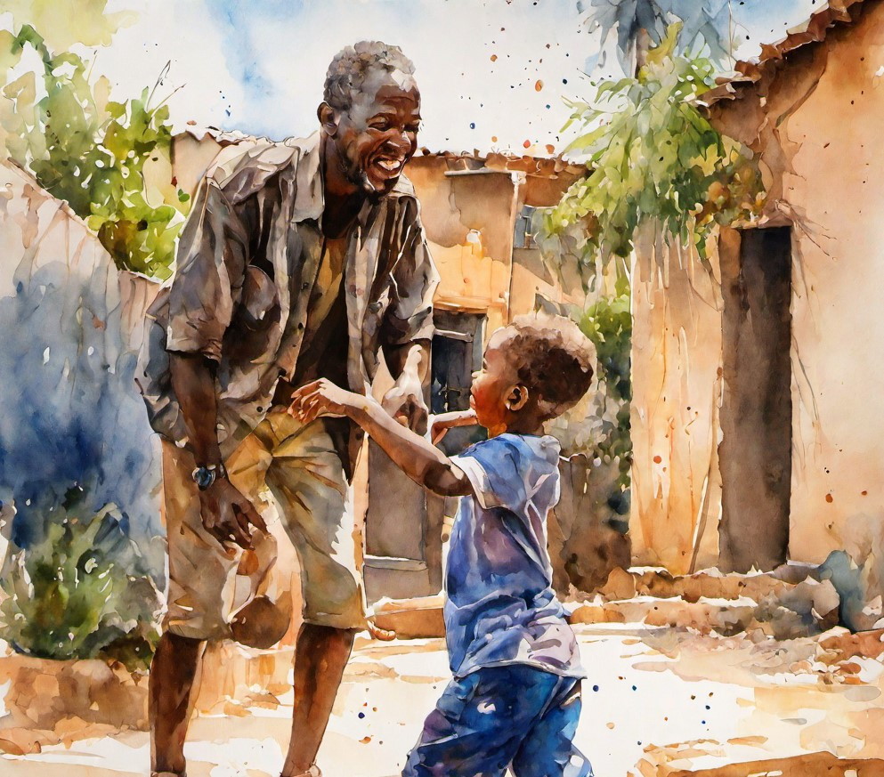
OUR RESPONSIBILITY
To help adults to keep you safe and happy when you are with us, we wrote a set of good rules that they must follow. It’s called a safeguarding policy.
Adults should:
· Always listen to you if you want to talk or need some help (remember they will always take you seriously)
· Never hit or hurt you in any way.
· Always use positive and non-violent ways of speaking
· Never meet you alone where others can’t see you both.
· Never touch you in a way that you don’t like, like touching your private parts
· Always ask for your permission to take photos, tell your story or share them with others.
· Never do anything that might put you in danger or at risk.
· Tell you about your rights and how to ask for help if you have a problem.

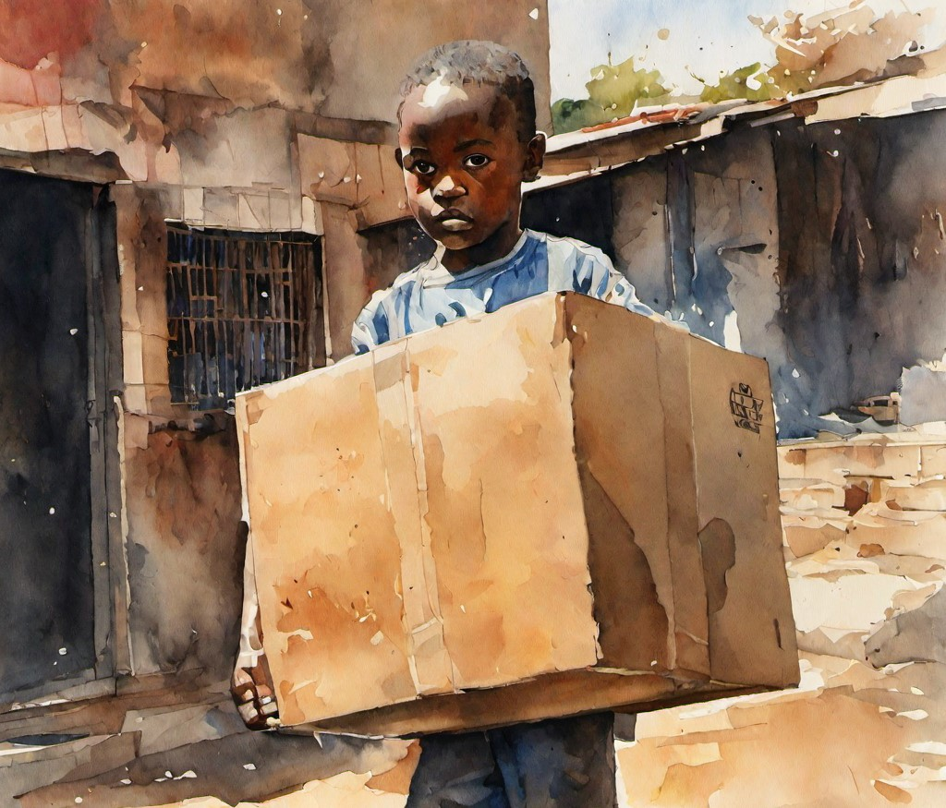
NO ONE HAS THE RIGHT TO HURT YOU

If it happens, it is never your fault. If you are worried about your safety and protection, or the safety and protection of another child, tell someone you trust.

You can always:
Ø Speak with any adult working at……………………… (the organization)
Ø Speak to a focal point [insert name and contact details]
Ø Call this number: [insert a number or a Helpline number]
Ø [Insert other local reporting measures, if any].

HOW WE KEEP YOU SAFE
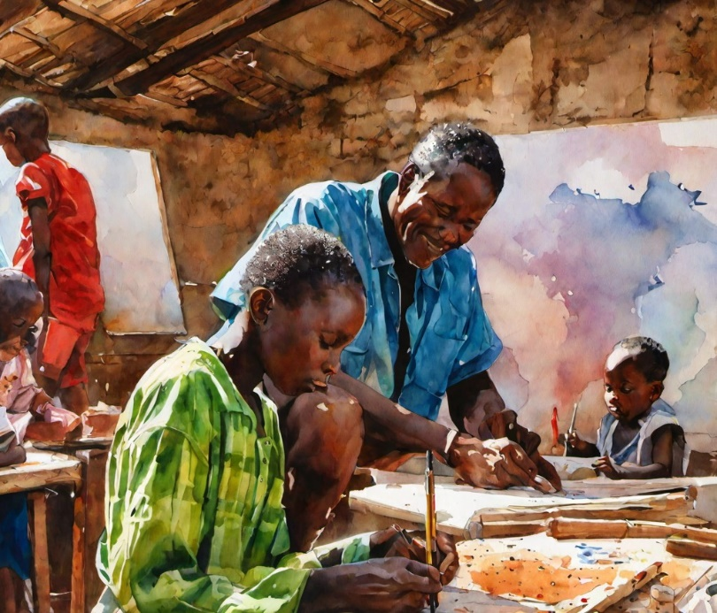

Remember:
All children have the right to grow up healthy and safe.
Prevent abuse before it happens.
We will make sure that you and everyone around you know about your rights, how to recognize what can hurt you, and where to get help if you are worried or unhappy.
We will do our best to spot if there are any risks of harm when you are with us, and how to plan activities that you can enjoy.
It is important that you share with us your feelings and opinion about the quality of the time you spend with us so we can always improve.

Don’t keep it a secret.
No one should hurt you. Unfortunately, some people do harm children. There are people that are responsible for making sure that you are and feel safe and we make sure you know them in person.
If someone – anyone hurts you or if you see a person hurting another child during an activity, do not be scared to tell it to someone as soon as you can.
There are many people at (the organization) for you to talk to and to ask for help. It doesn’t matter if you are just worried or not sure. We will take seriously all your worries and we will not share what you tell us to anyone if it is not necessary for your safety.
If you are worried or unhappy about something, tell a trusted adult about it.
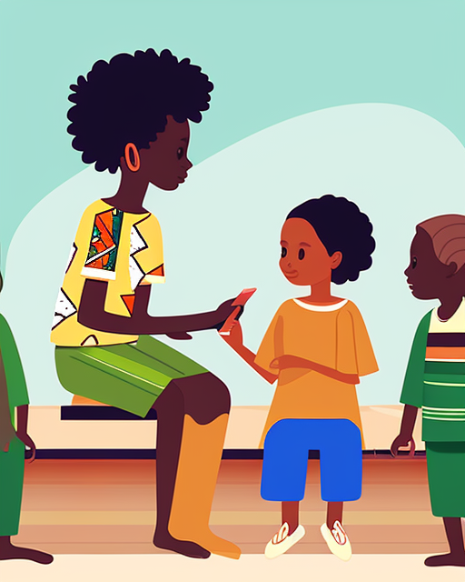

If something happens, we will always respond.
If we have any concern that something can cause harm to you or other children, people at (the organization) will try to learn more about the situation.
Sometimes they will need to work with other people – like doctors, social workers, or the police – that can help understand how to better protect you and to deal with the problem.
If we find out that someone working with or for (organization) has broken the rules, they must follow to keep you safe, (organization) will not let rule-breaking go.
You will always be supported if someone tried to or did hurt you.
We will connect you with people capable of assisting you.

Child-friendly reporting poster/leaflet template

What should I do if someone hurts me or makes me feel unsafe?
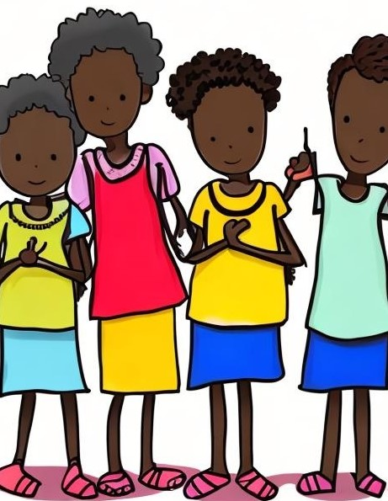
What will happen if I tell a grown up at (organization) that someone has hurt me, frightened me or been bad to me?
1. The grown up will listen to me kindly.
2. The grown up will keep what you say confidential and only tell someone who can help you.
3. The grown up will tell (name of the designated focal point) what has happened to you.
4. If (name of the designated focal point) is not there, (name of the manager or another senior trusted adult with a safeguarding background) will be told.
5. They will decide what needs to be done to help you. He/She may need to ask other grown ups to help you too.

Child-friendly feedback questionnaire template
Can you tell a trusted adult if someone is being mean to you or making
you feel scared?
🙂 | 😐 | 🙁
Do you know who you can talk to if someone makes you feel uncomfortable or unsafe?
🙂 | 😐 | 🙁
Should you share personal information, like your full name and address, with strangers?
🙂 | 😐 | 🙁
Have you seen our child safeguarding policy?
🙂 | 😐 | 🙁
Do you know where you can get an incident form?
🙂 | 😐 | 🙁
Were you given enough information and explanation about child safeguarding?
🙂 | 😐 | 🙁
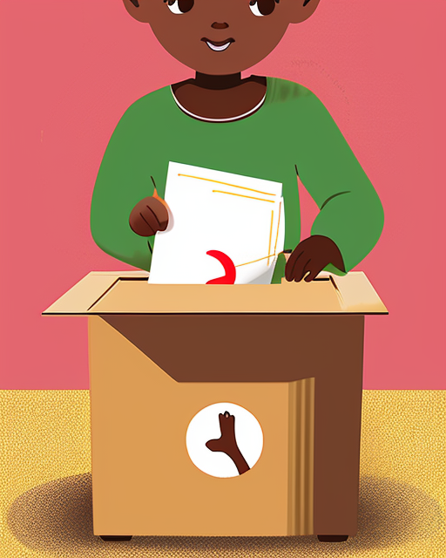

Section 3.2: More links to additional useful resources
The Convention of the rights of the child: the child-friendly version
Your first step to child safeguarding - Why child safeguarding? Child safeguarding is the responsibility that organizations have to make sure their staff, operations, and programs do no harm to children.
The ICS Standards - The International Child Safeguarding Standards (ICS Standards) represent a commitment by organizations to “do no harm” when they come into contact with children, and that they meet the responsibilities set out in the UN Convention on the Rights of the Child to protect children from all forms of abuse, neglect, exploitation and violence.
Child-friendly and simplified articles of the Convention of the rights of the child
UN Child Safeguarding Policy - UN personnel have specific responsibilities to report cases of sexual exploitation and abuse perpetrated by UN personnel.
Safeguarding at USAID - This handout summarizes USAID’s PSEA, C-TIP, and child safeguarding policies, and related requirements. Together, these requirements support a framework for the implementation of preventative protection and compliance measures across agency programming, especially for populations who may be at increased risk of harm.
USAID - Responsibility, Safeguarding and Compliance - The Responsibility, Safeguarding, and Compliance Division (M/MPBP/RSC) promotes effective stewardship of taxpayer dollars and protects the integrity of USAID’s programs. M/MPBP/RSC improves oversight of USAID implementing partners by promoting compliance with financial, safeguarding, and programmatic requirements.
USAID’s Guidance on Child Safeguarding for Implementing Partners - This guidance for implementing partners envisions a collaborative effort to ensure that no child is subject to child abuse, exploitation, or neglect in any USAID-funded program by increasing partner’s awareness of practical steps to prevent, stop, and respond to child abuse, exploitation, and neglect.
Protection of children against sexual exploitation and abuse - Child-friendly, multidisciplinary and interagency response inspired by the Barnahus model (2018) - Barnahus is a child friendly, multidisciplinary and interagency response model to child sexual abuse and provision of services for child victims and witnesses of violence. The Barnahus model puts the best interest of the child at the heart of investigative procedures, while taking into account that the child’s disclosure is key to identify and investigate child abuse both for criminal and for protective and therapeutic purposes.
Creating child-friendly versions of written documents: A guide - This guide was written by Professor Laura Lundy of the Centre for Children’s Rights at Queen’s University Belfast and includes examples of child-friendly documents produced in collaboration with Dr Bronagh Byrne, Dr Michelle Templeton and children and young people.
Guidelines for developing child-friendly reports - Guidelines for United Nations entities, agencies, and programs, developed to support those who engage with children, in the elaboration of child-friendly materials.
The Nine Basic Requirements for Meaningful and Ethical Children’s Participation

https://resourcecentre.savethechildren.net/pdf/SAMPLE+DRAFT_Definitions+of+Child+Abuse+and+Possible+indicators.doc/
USAID’s Guidance on Child Safeguarding for Implementing Partners | Work with USAID | Preventing Sexual Misconduct | U.S. Agency for International Development
USAID Best Practices for Complying with Child Safeguarding Requirements | Basic Page | U.S. Agency for International Development
110723 REPORTING SAFEGUARDING VIOLATIONS CONNECTED TO USAID'S PROGRAMS.pdf - Google Drive
KCS_GUIDANCE_ManagementCSAllegations_EN-2016_2020.pdf (keepingchildrensafe.global)
LIVES CC-VAC: Principles of Working with Children and Adolescents at Risk of or Experiencing Violence Against Children (VAC).
USAID Standard Provisions for US NGOs, ADS Reference 303maa | Automated Directives System | U.S. Agency for International Development (usaid.gov) for Non-US NGOs, ADS Reference 303mab | Document | U.S. Agency for International Development (usaid.gov), and for contract requirements, AAPD 18-03 | Document | U.S. Agency for International Development (usaid.gov).
Reporting Misconduct | Safeguarding and Compliance | U.S. Agency for International Development (usaid.gov)
Taken from LIVES CC-VAC: Principles of Working with Children and Adolescents at Risk of or Experiencing VAC/Referral Systems
Taken from LIVES CC-VAC: Principles of Working with Children and Adolescents at Risk of or Experiencing VAC/ Sample Language on Mandatory Reporting Requirements
Legislation may differ from country to country. Make sure you follow your local laws and policies on medical and service consent.
Learn and adhere to local laws, as legislation may differ in various countries.
Taken from LIVES CC-VAC: Providing First-Line Support to Children and Adolescents Who Have Experienced Violence in USAID's HIV Programs: First-Line Support (LIVES CC): Listen, Inquire, Validate, Enhance Safety
WHO, Responding to child maltreatment: a clinical handbook for health professionals, 2022. https://www.who.int/publications/i/item/9789240048737
For further information on LIVES and LIVES CC, please refer to ‘Providing First-Line Support to Children and Adolescents Who Have Experienced Violence in USAID's HIV Programs: First-Line Support (LIVES CC): Listen, Inquire, Validate, Enhance Safety.’
lundy_model_of_participation_0.pdf (europa.eu)
Creating child-friendly versions of written documents: A guide (qub.ac.uk)
So you want to consult with children? A toolkit of good practice | Save the Children’s Resource Centre

